
GASGUARD: INTELLIGENT LPG LEAK DETECTION AND AUTOMATIC SAFETY RESPONSE SYSTEM
FINAL YEAR
PROJECT PHASE-I REPORT
Submitted by
M.Rakshitha (23619124)
S.Lochana (23619136)

BACHELOR OF TECHNOLOGY CSE –
ARTIFICIAL INTELLIGENCE AND MACHINE LEARNING

DEPARTMENT OF ARTIFICIAL INTELLIGENCE AND MACHINE LEARNING
SCHOOL OF ENGINEERING
VELS INSTITUTE OF SCIENCE, TECHNOLOGY AND ADVANCED STUDIES
(VISTAS)
CHENNAI
OCTOBER 2026

BONAFIDE CERTIFICATE

Certified that this project report “GASGUARD: INTELLIGENT LPG LEAK DETECTION AND AUTOMATIC SAFETY RESPONSE SYSTEM” is the Bonafide work of M. RAKSHITHA (23619124) and S. LOCHANA (23619136), who carried out the project under my supervision. Certified further that, to the best of my knowledge, the work reported here does not form part of any other project report or dissertation on the basis of which a degree or award was conferred on an earlier occasion on this or any other candidate.

SIGNATURE OF THE HOD SIGNATURE OF THE SUPERVISOR

Dr.K.Ulagapriya M.E.,Ph.D. Dr. G. Revathy, M.E., Ph.D.
Head of the Department Assistant Professor
Department of AIML Department of AIML
School of Engineering School of Engineering
VISTAS VISTAS
Chennai- 600117 Chennai – 600 117

Submitted for the Project Work and Viva-Voce examination held on ……………… at Vels Institute of Science, Technology and Advanced Studies (VISTAS), Chennai – 600 117.

INTERNAL EXAMINER EXTERNAL EXAMINER

ACKNOWLEDGEMENT

It is certainly a great delight and proud privilege to acknowledge the help and support I received from the positive minds around me in making this venture a successful one. The infrastructural support with all kinds of lab facilities have been a motivating factor in this completion of project work, all because of FOUNDER & CHAIRMAN, Shri. Dr. ISHARI K. GANESH., with great pleasure that I take this opportunity to thank him. I am grateful to our HEAD OF THE DEPARTMENT, Dr. K. Ulagapriya., for her continuous support for the project, from initial advice and contacts in the early stages of conceptual inception, and through on-going advice and encouragement to this day. I extend our warmest thanks to my INTERNAL GUIDE, Dr. G. Revathy , who has patiently guided and provided us with invaluable advice and help. I am thankful to my Project Coordinator Ms. S.J. Kavitha, I would like to express my greatest gratitude to our Staff members, Librarian, and Non-teaching staff members of Computer Centre, who have helped and supported me throughout. Last but not the Least, I wish to thank my parents and my friends for their individual support and interest who has inspired me and encouraged me to go in my own way, without them I would be unable to complete this project.

M. RAKSHITHA - 23619124
S. LOCHANA - 23619136

TABLE OF CONTENTS
ABSTRACT iii
LIST OF FIGURES iv
LIST OF ABBREVIATIONS I
1. INTRODUCTION 1
1.1 OVERVIEW OF THE PROJECT 1
1.2 SCOPE AND OBJECTIVE 3
2. LITERATURE REVIEW 6
2.1 LITERATURE OVERVIEW 6
2.2 LITERATURE SURVEY 6
2.3 COMPARATIVE ANALYSIS WITH THE SURVEYED WORK 8
2.4 RESEARCH GAP 9
3. SYSTEM DESIGN 11
3.1 EXISTING SYSTEM 11
3.2 PROPOSED SYSTEM 11
3.3 SYSTEM ARCHITECTURE 12
3.4 HARDWARE REQUIREMENTS 15
3.5 SOFTWARE REQUIREMENTS 19
3.6 NON-FUNCTIONAL REQUIREMENTS AND DESIGN CONSIDERATIONS 20
4.IMPLEMENTATION 21
4.1 METHODOLOGY 21
4.2 IMPLEMENTATION 23
4.2.1 Module 1: Sensor Interface and Health Check 23
4.2.2 Module 2: Gas Level Processing and Severity Classification 23
4.2.3 Module 3: Indication and Display 24
4.2.4 Module 4: Ventilation Control 24
4.2.5 Module 5: Regulator Shut-Off 24
4.2.6 Module 6: Main Control Loop 25
4.2.7 Calibration of Thresholds 25
4.2.8 Execution Flow 26
4.2.9 Design Rationale 26
4.3 THEORETICAL BACKGROUND 26
4.4 INSTALLATION, OPERATION AND MAINTENANCE 28
5.CONCLUSION AND FUTURE WORK 32
5.1 CONC+.LUSION 32
5.2 FUTURE WORK 33
5.3 SOURCE CODE 34
5.4 RESULTS 38
5.5 HARDWARE OUTPUTS 40
5.6 APPENDIX: ALGORITHM 43
6.REFERENCES… 43
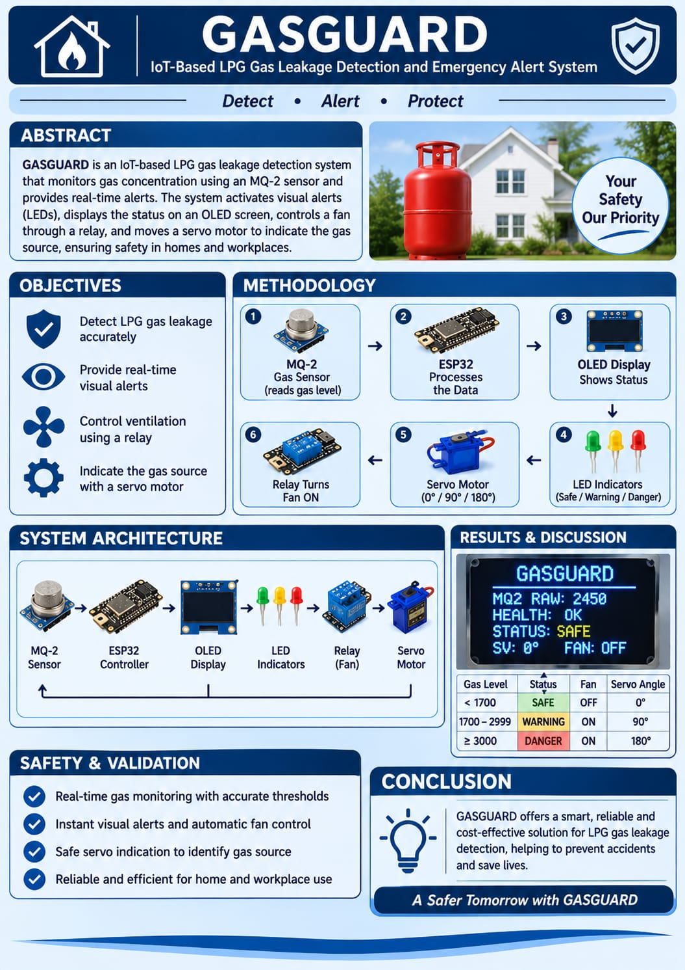

LIST OF FIGURES
Figure No. | Figure Names | Page No.
Figure 2.1 | Comparison of GasGuard with Existing LPG Leak Detection Systems | 9
Figure 3.1 | Proposed GasGuard Framework for LPG Leak Detection and Automatic Safety Response | 12
Figure 3.2 | Execution Flow of GasGuard from Basic Non-Zero Sensor-Reading Check to Automatic Safety Response | 14
Figure 3.3 | Severity States and Transitions in GasGuard | 15
Figure 3.4 | ESP32 Development Board | 16
Figure 3.5 | MQ-2 Gas Sensor | 16
Figure 3.6 | Servo Motor | 16
Figure 3.7 | Exhaust Fan | 17
Figure 3.8 | LEDs Used for Status Indication | 17
Figure 3.9 | OLED Display | 17
Figure 3.10 | LPG Regulator | 18
Figure 3.11 | 1-Channel Relay Module | 18
Figure 3.12 | Circuit Connection Diagram of GasGuard | 19
Figure 5.1 | Experimental Setup of the GasGuard Prototype | 40
Figure 5.2 | Prototype Indicating SAFE Status | 41
Figure 5.3 | Prototype Indicating DANGER Status | 41
Figure 5.4 | Prototype Indicating CRITICAL Status | 41
Figure 5.5 | Performance Analysis of GasGuard | 42

Table No. | Table Names
Table 1.1 | Target Users and How GasGuard Supports Them
Table 2.1 | Comparison Table
Table 2.2 | Study of Gas Leakage Detection Systems for Safety
Table 3.1 | Advantages of GasGuard over Existing Approaches
Table 3.2 | Severity States, Indication and Automatic Action
Table 3.3 | Hardware Components and Their Functions
Table 3.4 | Pin Mapping of the Prototype
Table 3.5 | Software and Tools
Table 4.1 | Calibration Values Used in the Prototype
Table 4.2 | Typical Specifications of the Main Components
Table 4.3 | Bill of Materials
Table 4.4 | Troubleshooting Guide
Table 5.1 | Source Code
Table 5.2 | Summary of Functional Tests
Table 5.3 | Performance of GasGuard under Different Conditions
Table 5.4 | Feature Comparison of Existing and Proposed Systems
Table 5.5 | Test Case Matrix
LIST OF TABLES

LIST OF ABBREVIATIONS

ABBREVIATION | FULL FORM
AC | Alternating Current
ADC | Analog-to-Digital Converter
AI | Artificial Intelligence
DC | Direct Current
GPIO | General Purpose Input/Output
GSM | Global System for Mobile Communications
I2C | Inter-Integrated Circuit
IDE | Integrated Development Environment
IoT | Internet of Things
LCD | Liquid Crystal Display
LED | Light Emitting Diode
LPG | Liquefied Petroleum Gas
ML | Machine Learning
OLED | Organic Light Emitting Diode
PWM | Pulse Width Modulation
SMS | Short Message Service

ABSTRACT

Liquefied Petroleum Gas (LPG) leakage can occur suddenly during the normal use of cylinders in homes, hotels, restaurants and other places, and can cause fire, loss of property and human casualties if it is not detected and controlled in time. Most existing detection systems sense the gas and sound an alarm, leaving the corrective action to the user, and many of them trust their gas sensor without checking its condition. Systems that depend on the internet or on GSM messages may also fail when the network fails. This project presents GasGuard, a low-cost, ESP32-based LPG leak detection and automatic safety response system. An MQ-2 gas sensor is used to sense LPG, and the condition of the sensor is checked, through a warm-up, range and stability test, before the gas concentration is evaluated. The concentration is compared with predefined thresholds and classified into three severity states: SAFE, WARNING and DANGER, which are shown through green, yellow and red LEDs and on an OLED display. When the leak reaches the DANGER level, the ESP32 drives a servo motor to turn the LPG regulator OFF and switches an exhaust fan ON through a relay to remove the accumulated gas. The whole function runs locally, without cloud or GSM connectivity. The prototype was tested functionally using a gas lighter as a controlled LPG source. The system sensed the gas, classified the severity, updated the display and performed the automatic regulator shut-off and ventilation. In the tests, detection accuracy was 100% for the Safe, Danger and Critical conditions, with severity levels of 33%, 67% and 100% and sensor responses of 44.6%, 52.4% and 100% respectively. These are functional results from a laboratory prototype and not a calibrated measurement of sensor accuracy; calibration against known gas concentrations and testing under varied conditions remain future work.
Keywords
LPG Leakage Detection, MQ-2 Gas Sensor, ESP32, Sensor Health Monitoring, Gas Severity Analysis, Automatic Regulator Control, Exhaust Fan, Embedded Safety System.

CHAPTER 1
INTRODUCTION

1.1 OVERVIEW OF THE PROJECT
Liquefied Petroleum Gas (LPG) is one of the most widely used cooking fuels in homes, hotels, restaurants, hostels and small commercial kitchens. It is convenient, portable and efficient, but it is also dangerous when it escapes. A leak can occur at the cylinder valve, the regulator, the rubber hose or the connected appliance, and often it gives no visible warning. The escaping gas mixes with air, collects in closed spaces and can ignite from a spark as small as that of a switch, a refrigerator relay or a lighter. A delay of even a few minutes between the start of a leak and the response can decide whether the result is a minor scare or a serious fire.
Most low-cost detectors available today only sound an alarm and leave the next steps to a person. The occupant must notice the alarm, reach the cylinder, close the regulator and ventilate the room, all while a flammable atmosphere is building up. This is not possible when the house is empty, when the occupants are asleep or when the leak develops quickly. GasGuard is an embedded safety system that closes this gap. It monitors LPG continuously, decides how serious a leak is, informs the user locally and, when the situation becomes dangerous, acts automatically by turning the LPG regulator OFF and switching an exhaust fan ON.

1.1.1 Motivation
Gas leak detectors are good at one thing: noticing that gas is present. They seldom check whether their own sensor is healthy, they rarely distinguish a trace of gas from a dangerous concentration, and many of them depend on a mobile network, a cloud dashboard or a GSM message to be useful. A detector whose sensor has failed silently gives the user a false sense of safety, which is worse than having no detector at all. A detector that depends on the internet is of little help when the router is off or the signal is weak. GasGuard was built to answer three practical questions with one low-cost device: is my sensor working, how serious is the leak, and what should be done about it right now without waiting for a person.

1.1.2 Background: LPG and Its Hazards
LPG is a mixture of hydrocarbon gases, mainly propane and butane, stored as a liquid under pressure in a cylinder and released as a gas through a regulator. Three properties make a leak dangerous. First, LPG vapour is heavier than air, so it does not disperse upwards like natural gas but sinks and collects near the floor, in drains and in low corners. Second, it is flammable over a range of concentrations in air, roughly from about two per cent to about ten per cent by volume; a mixture within this range can ignite or explode. Third, pure LPG has almost no smell, so a distinctive odorant is added so that people can notice a leak, but a person may not be present, may be unable to smell it, or may become accustomed to the odour.
For these reasons a leak should be detected at a concentration far below the flammable range, and the gas supply should be stopped quickly. Ventilation then removes the gas that has already escaped. The two actions, stopping the source and clearing the air, are exactly the two automatic responses implemented in GasGuard.

1.1.3 Problem Statement
Current LPG leak detection systems leave several problems unsolved:
- Many systems only detect the gas and raise an alarm; the corrective action is left to the user.
- The gas sensor is trusted without any check of its own condition, so a faulty or unstable sensor can silently give a false “Safe” result.
- A small trace of gas and a dangerous concentration are often treated alike, so the response is not proportionate to the risk.
- IoT-based and GSM-based designs depend on network availability, so their alerts or remote actions may fail when the network fails.
- Designs that add cameras, sensor fusion or machine learning are costly and complex for ordinary homes.
The problem addressed in this project is therefore to design, implement and test a low-cost embedded system that checks whether the averaged sensor reading is non-zero, classifies the severity of an LPG leak in real time, indicates the condition locally and takes automatic action to stop the gas supply and ventilate the area, without relying on any network connection.

1.1.4 Overview of the Approach
GasGuard is organised as a pipeline of connected stages. An MQ-2 gas sensor produces an analog voltage that rises with the concentration of combustible gas. The ESP32 microcontroller first warms the sensor up and carries out a health check; if the sensor is not healthy, a sensor fault is reported and no gas decision is made from it. When the sensor is healthy, the ESP32 reads and filters the analog value and compares it with predefined thresholds, which divide the range into three severity states: SAFE, WARNING and DANGER. The state is shown by a green, yellow or red LED and as text on an OLED display. When the state is DANGER, the ESP32 drives a servo motor that turns the LPG regulator OFF and switches an exhaust fan ON through a relay module. The system then continues to monitor and update the display.

1.1.5 Key Contributions
- An integrated, low-cost ESP32-based pipeline that links basic non-zero sensor-reading checking, LPG detection, severity classification, local indication, automatic regulator shut-off and ventilation in one device.
- A basic non-zero sensor-reading check that is carried out before the gas concentration is evaluated, which is not reported in the surveyed LPG leak detection systems.
- A four-level severity classification (Safe, Warning, Dangerous, Critical) that makes the response proportionate to the leak.
- Fully local operation: detection, decision and response do not depend on the internet, a cloud service or a GSM module.
- A working prototype tested with a gas lighter as a controlled LPG source, with a statement of what has and has not yet been validated.

1.1.6 Organisation of the Report
Chapter 1 introduces the problem, scope and objectives. Chapter 2 reviews the literature and identifies the research gap. Chapter 3 describes the existing and proposed systems, the architecture, and the hardware and software requirements. Chapter 4 presents the methodology and the implementation of each module. Chapter 5 concludes the report, lists future work, reproduces the source code and presents the test results and hardware outputs.

1.2 SCOPE AND OBJECTIVE

1.2.1 Scope
The scope of the project covers real-time monitoring of LPG leakage using an MQ-2 sensor connected to an ESP32 development board, a basic non-zero sensor-reading check, classification of the gas level into four severity states, indication through three LEDs and an OLED display, automatic regulator shut-off using a servo motor and automatic ventilation using a relay-driven exhaust fan. The control program is written in Embedded C/C++ in the Arduino IDE. Testing is carried out with a gas lighter as a controlled source of LPG on a prototype with a mock regulator mechanism.
The following items are outside the scope of the present prototype and are listed as future work in Chapter 5: weight monitoring of the cylinder with a load cell, an audible buzzer or siren, remote notification through a mobile application or messaging service, long-term calibration against reference gas concentrations, and a formal evaluation under a wide range of temperature, humidity and gas conditions.

1.2.2 Objectives
- To verify the condition and stability of the MQ-2 gas sensor before the gas concentration is evaluated.
- To read the LPG level in real time and compare it with threshold values to decide the severity state.
- To classify the gas level into four states: SAFE, WARNING and DANGER.
- To indicate the state locally using green, yellow and red LEDs and an OLED display.
- To turn the LPG regulator OFF automatically, using a servo motor, when a DANGER leak is detected.
- To switch an exhaust fan ON automatically through a relay module so that the accumulated gas is removed.
- To keep the system low-cost and independent of cloud or GSM connectivity.
- To test the integrated system on a hardware prototype and to report honestly which claims are supported by the tests and which are not.

1.2.3 Target Users and Applications
Table 1.1 – Target users and how GasGuard supports them
User group | Need | Supporting module
Households using LPG cylinders | Protection when no one is watching the cylinder | Detection, automatic shut-off, ventilation
Hotels, restaurants and canteens | Early warning and automatic control in busy kitchens | Severity states, LED and OLED indication
Hostels and institutional mess halls | Low-cost safety device that can be installed per kitchen | Complete ESP32 prototype
Laboratories and small workshops | Local response without a network | Local control logic, relay and servo
Students and researchers | A documented, extendable embedded safety design | Source code, wiring and test results

1.2.4 Expected Benefits
- Safety: the supply is shut off and the area is ventilated automatically, without waiting for the user.
- Trust: the sensor is checked before its readings are used, so a faulty sensor is reported instead of being trusted.
- Proportionate response: four severity states mean that a trace of gas gives a warning while a dangerous leak triggers action.
- Independence: the system works without internet, cloud or GSM service.
- Low cost: the prototype uses inexpensive, widely available modules.
- Extendability: a load cell, a siren or remote alerts can be added without changing the basic design.

1.2.5 Methodology Summary
The development followed an iterative sequence: study of existing systems, selection of components, interfacing and testing of each module, development of the control algorithm, integration and testing of the complete system. Each module was verified on the hardware before the next was added. The integrated prototype was then tested using a gas lighter as a controlled LPG source, with the Serial Monitor used to observe the raw sensor values and to verify the thresholds and the responses (Section 4.1 and Section 5.4).

1.2.6 Limitations of the Present Work
The results reported in this document come from functional testing of a laboratory prototype with a gas lighter as the gas source. They show that the integrated pipeline works, but they do not establish the sensor’s accuracy against a calibrated reference gas concentration, nor the behaviour of the system over long periods, in different climates or on a live cylinder installation. The MQ-2 is a general-purpose combustible-gas sensor: its output depends on temperature and humidity, it needs a warm-up period, and it responds to several gases other than LPG, including smoke and alcohol vapour. The threshold values were set for the prototype and must be recalibrated for every sensor and installation. The regulator shut-off was demonstrated with a servo-operated mock mechanism. These limitations are discussed further in Chapter 5.

CHAPTER 2
LITERATURE REVIEW

2.1 LITERATURE OVERVIEW
Gas leakage detection has been studied for many years, and LPG leakage detection in particular has attracted a large number of low-cost embedded designs. Early designs consisted of an Arduino board, a gas sensor and a buzzer. Later work added displays, GSM text messages, Wi-Fi based cloud dashboards and mobile applications, and the most recent designs use sensor fusion, edge machine learning and camera-based verification.
This chapter reviews the research and systems relevant to GasGuard in six areas: LPG properties and leak hazards, gas sensing technology, Arduino-based detection with automatic shut-off, IoT-based monitoring, sensor fusion with edge intelligence and cylinder weight monitoring. It then discusses sensor reliability and embedded platforms. The chapter has four purposes:
- To identify the research gap in current LPG leakage detection systems.
- To trace how designs have moved from simple alarms to automatic and connected systems.
- To understand the role of sensor health in the reliability of threshold-based detection.
- To provide the theoretical foundation for the proposed GasGuard system.

2.2 LITERATURE SURVEY

2.2.1 LPG Properties and Leak Hazards
LPG is a mixture of propane and butane. Its vapour is heavier than air and settles at low levels, and it is flammable in air over a limited range of concentrations. Because of these properties, a leak in a closed kitchen can build up a flammable layer near the floor before it is noticed. Detection must therefore work at low concentrations and the response must be fast. The surveyed designs address this need with a gas sensor and a threshold, but they differ widely in what happens after the threshold is crossed.

2.2.2 Gas Sensing Technology
Almost all the surveyed LPG detectors use a metal-oxide semiconductor sensor of the MQ series, and in particular the MQ-2 [1], [2], [5], [7], [8]. The MQ-2 contains a tin dioxide sensing layer and an internal heater. In clean air the layer has a high resistance; when combustible gas such as LPG, propane, methane, hydrogen or smoke is present, the resistance falls, and a load resistor in the sensor module converts this change into a voltage that a microcontroller can read [10]. The sensor is inexpensive, sensitive and easy to interface, which explains its popularity. Its manufacturer’s data sheet also makes clear that the sensor needs a preheating period, that its output changes with temperature and humidity, and that it is not selective for one gas [10]. These properties mean that a threshold applied to the raw reading is only as trustworthy as the sensor’s condition, a point that most of the surveyed works do not address.

2.2.3 Arduino-Based Detection and Automatic Shut-Off
Gupta proposed an LPG leakage detector with automatic shut-off using an Arduino Uno and an MQ-2 sensor [2]. The system gives an alarm when leakage is detected and closes the gas pipeline through a solenoid valve in the case of a hazardous leak, with an LCD showing the gas status. Pamungkas et al. implemented an Arduino-based tool in which a buzzer and a blower fan deal with the leak at first, while a servo and spray-foam mechanism provide additional protection at high gas concentration; the average reaction time obtained was 9.56 seconds [7]. These two works are closest to GasGuard in that they combine detection with an automatic physical response. However, neither verifies the condition of the sensor before using its readings, and neither classifies the leak into more than a simple alarm and a hazardous stage.

2.2.4 IoT-Based Detection and Monitoring
A large group of works use a Wi-Fi capable board such as the NodeMCU ESP8266 or the ESP32 to send gas data to a mobile application or a cloud platform. Sitan and Ab Ghafar combined an MQ-2 sensor, a NodeMCU and the Blynk platform to detect LPG leakage and to monitor cylinder weight [5]. Novitaningrum et al. built a mitigation system with an MQ-2 sensor, an ESP8266, LEDs, a buzzer and the Blynk application, with local and remote alerts and detection reported within a range of 1–16 cm [8]. Sohal et al. developed the G.A.R.D. system with an ESP32, MQ-2, DHT22 and LoRa, providing local LED and buzzer alerts and a mobile application; testing showed reliable detection and notification within a 10–30 m radius [6]. Anjum et al. described a portable IoT gas sensor for smart cities that gives alerts through a buzzer and LED and displays the gas status [4], and Tukkoji and Kumar analysed a smart IoT-based gas leakage detection and controlling system with analog MQ-2 sensing [1]. These systems are strong in monitoring and notification, but their remote functions depend on network availability, and most stop at alerting rather than acting.

2.2.5 Sensor Fusion and Edge Intelligence
Altamash et al. presented an intelligent IoT-based fire and gas leakage detection system using an ESP32, sensor fusion, edge AI and an ESP32-CAM [3]. Gas, flame and temperature sensors are combined and visual confirmation is used to avoid false alerts, so that a real fire or gas leak can be distinguished from smoke and other disturbances. The approach improves the reliability of the alarm, but it adds cost and complexity, depends on cloud connectivity and has no automatic cut-off of the gas supply.

2.2.6 Cylinder Weight Monitoring
Asha et al. proposed an IoT-based CNG/LPG leakage alert and monitoring system using an Arduino Uno, a gas sensor, a load cell, an LCD, a buzzer and a GSM module [9]. The system detects leakage, monitors the cylinder weight, displays real-time values and sends SMS notifications. Weight monitoring warns the user when the cylinder is nearly empty and also provides an independent indication of gas consumption, but the surveyed design relies on GSM alerts and takes no automatic safety action. Cylinder weight monitoring is retained in GasGuard as a planned future extension.

2.2.7 Sensor Reliability and Health Monitoring
Metal-oxide gas sensors drift as they age, they take time to stabilise after power-up and their baseline changes with temperature and humidity [10]. A sensor whose heater has failed, whose wiring has come loose or whose output is stuck at an extreme can produce a perfectly steady reading that is meaningless. Threshold-based detection that does not check for such conditions can fail silently. In the surveyed literature, none of the five systems compared in Table 3 reports a basic non-zero sensor-reading check. Checking that the sensor has warmed up, that its output lies within a plausible range and that it is stable before accepting a reading is a simple and inexpensive measure that directly improves the dependability of the whole system.

2.2.8 Embedded Platforms
The ESP32 is a low-cost dual-core microcontroller with a 12-bit analog-to-digital converter, hardware PWM, I2C and built-in Wi-Fi and Bluetooth [11]. It is programmable from the Arduino IDE through the ESP32 board package [12]. Its processing power and peripheral set are sufficient to read a gas sensor, drive an OLED display [13], LEDs, a relay and a servo, and to run the control logic without an external computer, which makes it suitable for the stand-alone design proposed in this project. Altamash et al. [3], Sohal et al. [6] and others have used the same board in IoT designs; GasGuard uses it as a local controller.

2.3 COMPARATIVE ANALYSIS WITH THE SURVEYED WORK
Table 2 compares the main approaches found in the literature with the approach proposed in this project, and Table 3 summarises the detection method, the automatic safety action and the basic non-zero sensor-reading check of five of the surveyed works. Figure 1 shows the comparison graphically.
Table 2.1 – Comparison Table
Approach | Method | Strength | Limitation
Arduino with alarm and display [2], [4] | MQ-2 with buzzer, LED, LCD | Simple and low cost | User must act; no sensor check
Arduino with automatic action [2], [7] | Valve, servo or fan after threshold | Physical response to leak | No sensor health check; limited grading
IoT and mobile monitoring [5], [6], [8] | ESP8266/ESP32 with cloud or mobile app | Remote visibility | Network dependent; mostly alerts only
GSM alerting with weight monitoring [9] | Load cell, GSM SMS | Refill warning, SMS alerts | No automatic action; GSM dependent
Sensor fusion and edge AI [3] | Gas, flame, temperature, camera | Fewer false alarms | Costly; cloud dependent; no cut-off
GasGuard (proposed) | MQ-2 with health check and four severity states; relay fan and servo regulator | Verified sensor, graded local response, no network needed | Prototype stage; thresholds need calibration; no weight or siren yet

Table 2.2 – Study of gas leakage detection systems for safety
Existing research work | Detection method | Auto safety action | Sensor health check
Tukkoji & Kumar [1] | MQ-2 (analog) | Not found | Not found
Altamash et al. [3] | MQ-2 + sensor fusion (ML) | Not found | Not found
Sitan & Ab Ghafar [5] | MQ-2 (analog) | Not found | Not found
Pamungkas et al. [7] | MQ-2 (analog) | Found | Not found
Asha et al. [9] | Gas sensor (analog) | Not found | Not found

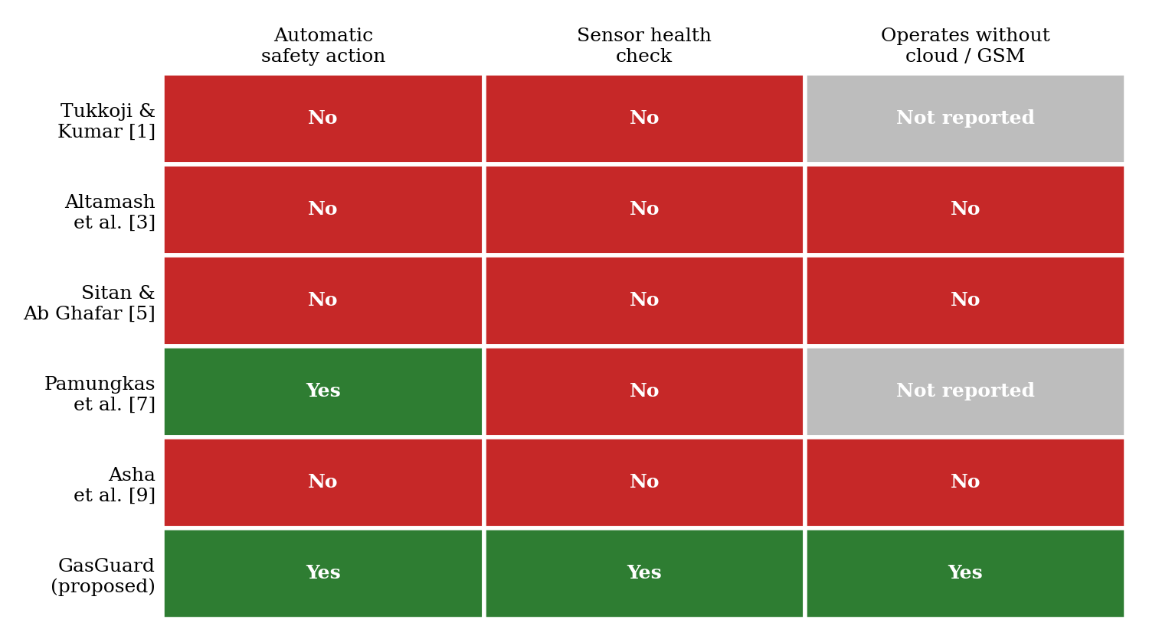
Figure 2.1 – Comparison of GasGuard with existing LPG leak detection systems

2.4 RESEARCH GAP
The survey shows mature, inexpensive methods for sensing LPG and for sending alerts, and a few designs that add an automatic physical response. What is largely missing is a system that checks whether the averaged sensor reading is non-zero, grades the severity of the leak and responds automatically, all without depending on a network. The specific gaps that motivate GasGuard are:
- The need to check the health of the gas sensor before it is used for detection is not emphasised in the surveyed works.
- Automatic regulator cut-off and exhaust fan activation together with severity analysis is rarely implemented in a single system.
- IoT-based systems depend on internet connectivity for remote control and monitoring, which fails when the network is unavailable.
- Threshold detection is affected by sensor and environmental variation, and most designs do not discuss how this is handled.
- Designs that add cameras or machine learning improve verification but are costly and complex for domestic use.
GasGuard addresses these gaps with an economical ESP32-based design that checks the sensor, detects LPG in real time, classifies the severity, indicates the state locally and automatically turns the regulator OFF and the exhaust fan ON.

CHAPTER 3
SYSTEM DESIGN

3.1 EXISTING SYSTEM
Existing LPG leakage detection systems typically consist of a gas sensor, a microcontroller and an alert device. Depending on the design the alert may be a buzzer and LED, a message on an LCD, a GSM text message, or a notification on a mobile application or cloud dashboard. A few designs add a solenoid valve or a servo for shut-off and some add a load cell for cylinder weight monitoring. The major limitations of the existing systems are:
- Detection without action: many systems only detect and display; the corrective action is left to the user.
- No sensor health verification: readings are used without checking whether the sensor is warmed up, stable and within a plausible range.
- Limited severity analysis: a trace of gas and a dangerous concentration are often handled in the same way.
- Network dependence: remote alerts rely on internet access or a GSM service and fail when it is unavailable.
- Cost and complexity: camera, edge-AI and multi-sensor designs raise the cost and the difficulty of installation.
An intelligent LPG safety system is therefore required that checks its sensor, grades the leak and responds automatically within one low-cost device.

3.2 PROPOSED SYSTEM
GasGuard is an intelligent LPG leakage monitoring and safety system that reacts as well as monitors. An MQ-2 gas sensor and an ESP32 monitor the environment. The function of the sensor is verified before readings are taken. The ESP32 analyses the gas level, decides the severity, and shows the result through LEDs and an OLED display. If the leakage becomes dangerous, the LPG regulator is switched OFF and the exhaust fan is switched ON automatically. All of this runs on the device itself, so the safety function does not depend on a network.

3.2.1 Features of the Proposed System
- Sensor health check: warm-up, range and stability checks before gas measurement.
- Real-time gas detection: the MQ-2 analog output is read and filtered continuously.
- Four severity states: SAFE, WARNING and DANGER, decided by threshold comparison.
- Local indication: green, yellow and red LEDs and a text status on the OLED display.
- Automatic regulator shut-off: a servo motor turns the LPG regulator OFF at the Dangerous and Critical levels.
- Automatic ventilation: a relay switches the exhaust fan ON at the Dangerous and Critical levels.
- Local operation: no cloud, internet or GSM module is required.

3.2.2 Advantages over Existing Systems
Table 3.1 – Advantages of GasGuard over existing approaches
Aspect | Existing systems | GasGuard
Response | Alarm only; user must act | Automatic regulator shut-off and ventilation
Sensor reliability | Reading trusted without checks | Health check before detection
Severity | Single threshold or two stages | Four states with proportionate action
Connectivity | Often cloud, Wi-Fi or GSM based | Fully local operation
Indication | Buzzer or remote notification | LEDs and OLED status at the device
Cost | Rises with cameras, ML or GSM | Low-cost modules on an ESP32

3.3 SYSTEM ARCHITECTURE
The GasGuard architecture consists of a sensing unit, a processing unit, an indication unit and a response unit. These components work together to detect a leak and to take action. Figure 2 shows the architecture and Figure 3 shows the execution flow.
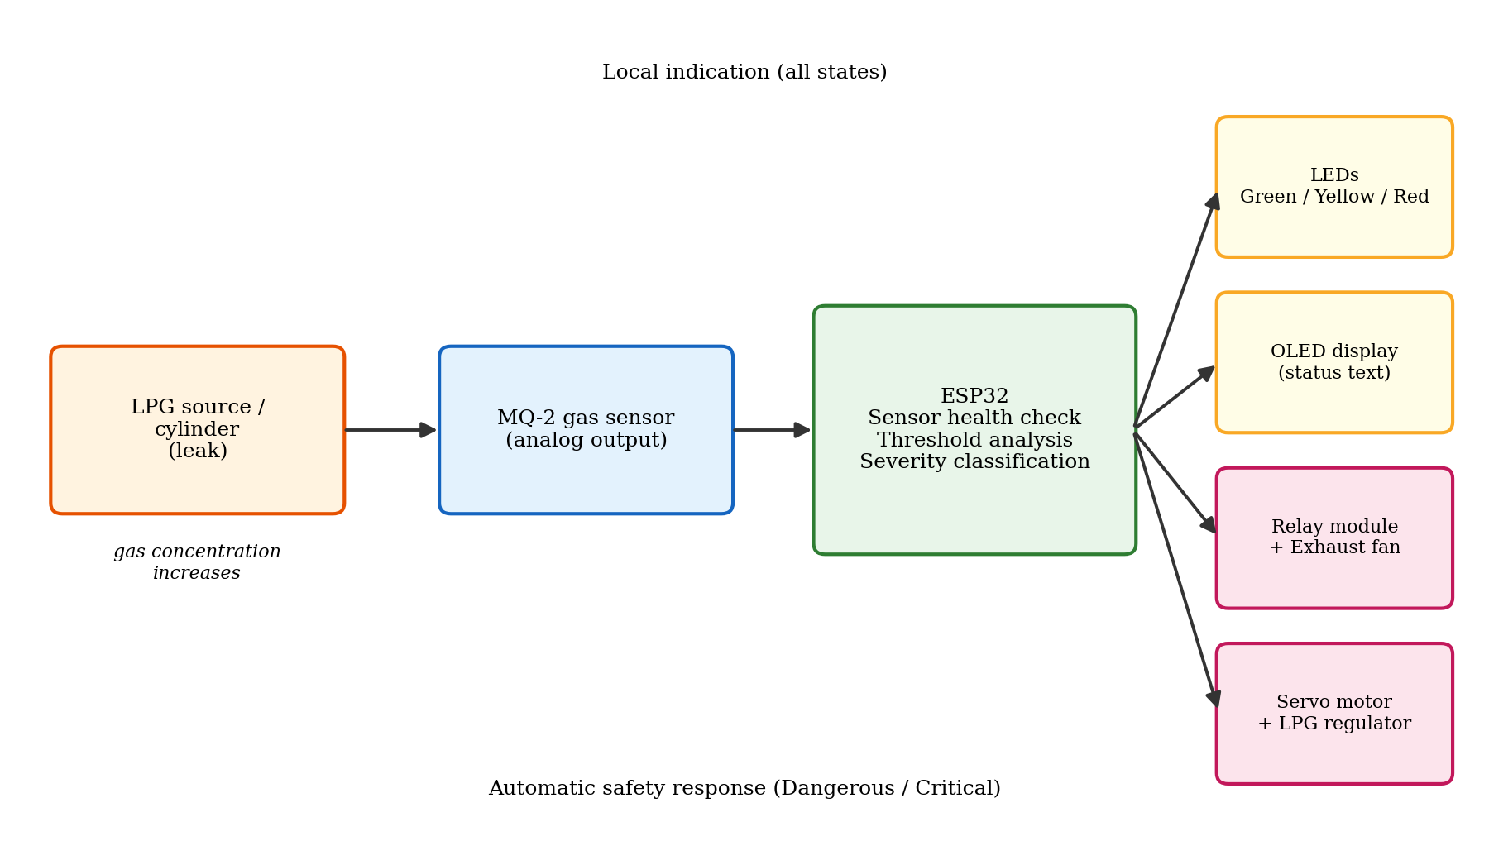
Figure 3.1– Proposed GasGuard framework for LPG leak detection and automatic safety response

3.3.1 Description of the Architecture
- Sensing unit (MQ-2 gas sensor): produces an analog voltage that rises as the concentration of combustible gas increases.
- Processing unit (ESP32): carries out the sensor warm-up and health check, reads and filters the analog value, compares it with the thresholds and decides the severity state.
- Indication unit (LEDs and OLED): shows the state as a green, yellow or red LED and as text on the OLED display.
- Ventilation unit (relay and exhaust fan): removes the accumulated gas when the state is DANGER.
- Shut-off unit (servo motor and regulator): turns the LPG regulator OFF at the Dangerous and Critical levels to stop the supply.
- Control program (Embedded C/C++): implements the algorithm on the ESP32 through the Arduino IDE.

3.3.2 Working Flow
When the system is switched on, the ESP32 initialises the sensor, the display and the outputs and lets the sensor warm up. The health check then decides whether the sensor can be trusted. If it cannot, a sensor fault is shown and the loop restarts. If it can, the ESP32 reads the gas level, classifies the severity and updates the LEDs and the display. If the state is DANGER, the exhaust fan is switched ON and the servo turns the regulator OFF. The system then continues to monitor, so that the display always shows the current condition.
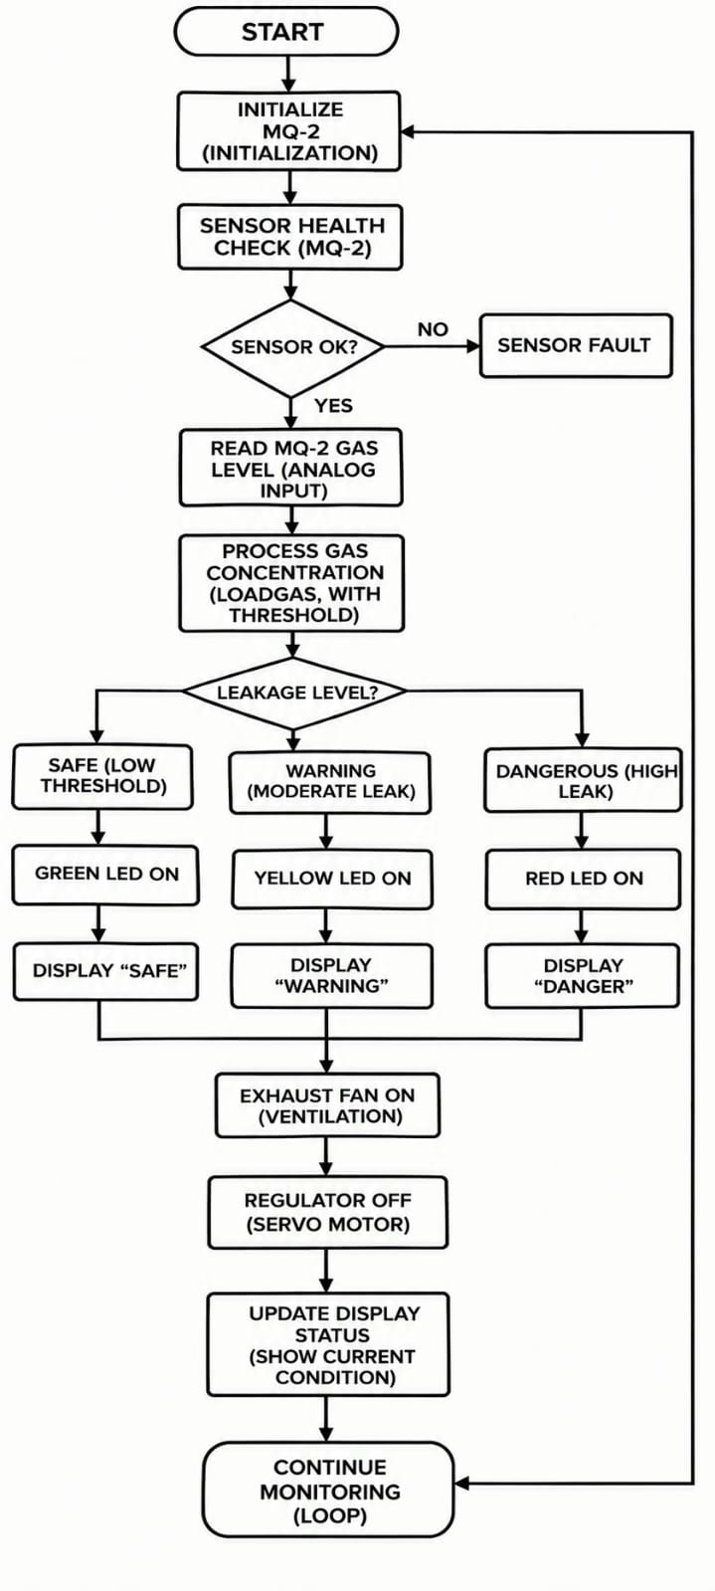
Figure 3.2 – Execution flow of GasGuard from basic non-zero sensor-reading check to automatic safety response

3.3.3 Severity States and Control Rules
Table 5 summarises the four severity states and the corresponding indication and action. The numerical thresholds that separate the states are set during calibration (Section 4.2.7). Figure 4 shows the transitions between the states.
Table 3.2 – Severity states, indication and automatic action
State | LED | OLED text | Automatic action
Safe | Green | SAFE | None; normal monitoring
Warning | Yellow | WARNING | None; user alerted by indication
Dangerous | Red | DANGER | Exhaust fan ON; regulator OFF
Critical | Red | CRITICAL | Exhaust fan ON; regulator OFF
Sensor fault | Red (blinking)* | SENSOR FAULT | No gas decision; fault reported
* The blinking pattern for the fault state is a design option of the control program.
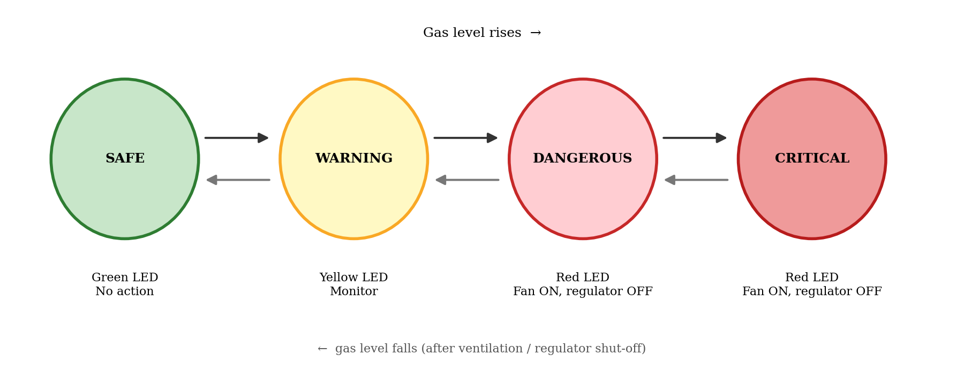
Figure 3.3– Severity states and transitions in GasGuard

3.4 HARDWARE REQUIREMENTS
Table 6 lists the hardware components used in the prototype and the function of each in the system. The pictures of the individual components follow in Section 3.4.1.
Table 3.3 – Hardware components and their functions
S.No | Component | Function in GasGuard
1 | ESP32 development board | Central controller; reads the sensor, runs the health check and classification, and drives all outputs.
2 | MQ-2 gas sensor module | Detects combustible gas including LPG and provides an analog voltage to the ESP32.
3 | Servo motor | Rotates the regulator mechanism to turn the LPG supply OFF.
4 | Exhaust fan | Removes accumulated gas from the area by ventilation.
5 | 1-channel relay module | Switching interface between the ESP32 and the exhaust fan.
6 | LEDs (green, yellow, red) | Indicate Safe, Warning and Dangerous/Critical conditions with series resistors.
7 | OLED display | Shows the current status text; connected over I2C.
8 | LPG regulator (mock mechanism) | Controls the LPG flow from the cylinder to the appliance; shut off by the servo.
9 | Power supply, breadboard and jumper wires | Power distribution and connections for the prototype.
10 | Gas lighter (test source) | Provides a controlled source of LPG for testing.

3.4.1 Description of the Components
ESP32 development board. The ESP32 (Figure 5) is the central processing unit of GasGuard. It receives the gas information from the MQ-2 sensor, evaluates it against the thresholds, determines the severity state, and controls the LEDs, the OLED display, the servo and the relay. It offers a 12-bit ADC, I2C and PWM peripherals on 3.3 V logic [11].
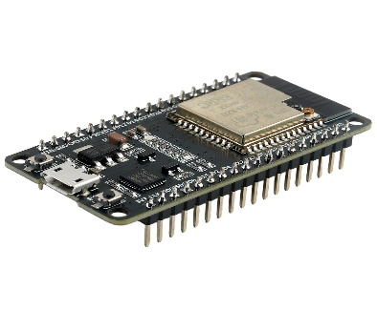
Figure 3.4– ESP32 development board
MQ-2 gas sensor. The MQ-2 (Figure 6) is the sensing element. It has a tin dioxide sensing layer with an internal heater, and its output voltage rises with the concentration of combustible gas [10]. The module provides both an analog output, used by GasGuard, and a digital comparator output, which is not used because it offers only a single fixed threshold.
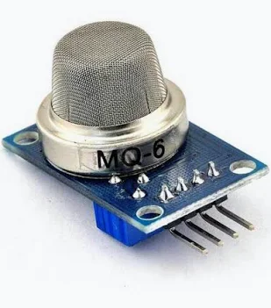
Figure 3.5– MQ-2 gas sensor
Servo motor. The servo motor (Figure 7) operates the automatic regulator shut-off. A servo is positioned by the width of a control pulse, so the ESP32 can command a closed and an open angle with a single signal pin. When a dangerous or critical condition is detected the servo turns the regulator mechanism to the OFF position.
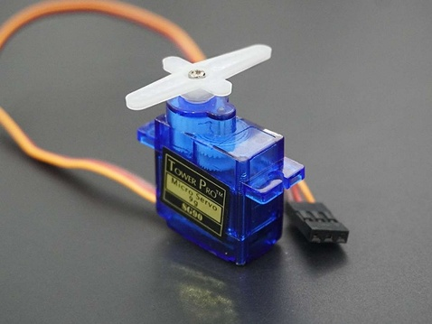
Figure 3.6 – Servo motor
Exhaust fan. The exhaust fan (Figure 8) provides ventilation when a high LPG level is sensed. It is switched through a relay module so that the ESP32 never has to supply the fan current.
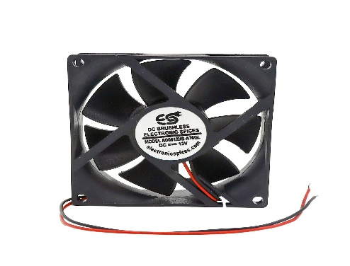
Figure 3.7– Exhaust fan
LEDs. Three LEDs (Figure 9) indicate the safety level: green for Safe, yellow for Warning and red for Dangerous and Critical. Each LED is connected through a series resistor to limit the current from the ESP32 pin.
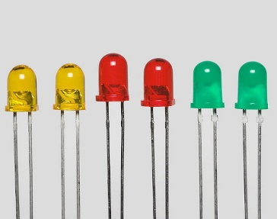
Figure 3.8– LEDs used for status indication
OLED display. The OLED display (Figure 10) shows the current status as text. It is connected to the ESP32 through the I2C bus and uses only two signal wires [13].
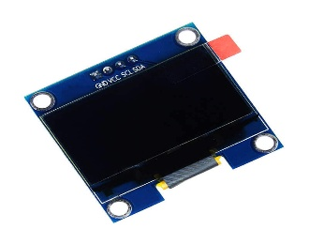
Figure 3.9 – OLED display
LPG regulator. The regulator (Figure 11) controls the flow of LPG from the cylinder to the appliance. In GasGuard it works with the servo-operated shut-off mechanism, which turns the regulator OFF on a dangerous or critical leak to stop further leakage.
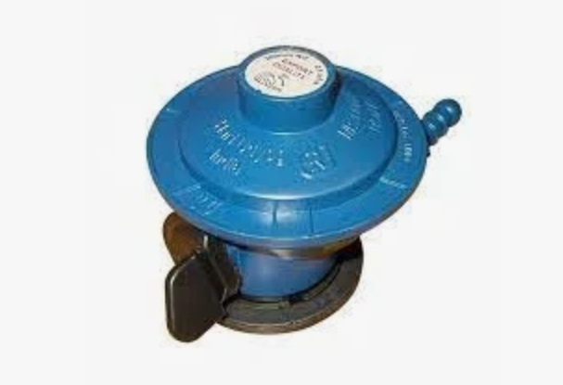
Figure 3.10 – LPG regulator
1-channel relay module. The relay module (Figure 12) is the switching interface between the ESP32 and the exhaust fan. The ESP32 drives only the low-current input of the relay, and the relay contacts switch the fan supply.
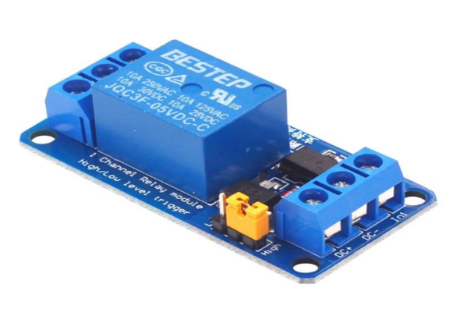
Figure 3.11– 1-channel relay module

3.4.2 Circuit Design and Connections
Figure 13 shows how the components are connected to the ESP32 and Table 7 lists the pin mapping. The MQ-2 analog output is connected to an ADC1 pin of the ESP32. ADC1 pins are used because the ADC2 channels cannot be used while the Wi-Fi radio is active, and using ADC1 keeps the design free to add wireless features later [11]. All grounds are joined so that the sensor, the controller and the outputs share a common reference.
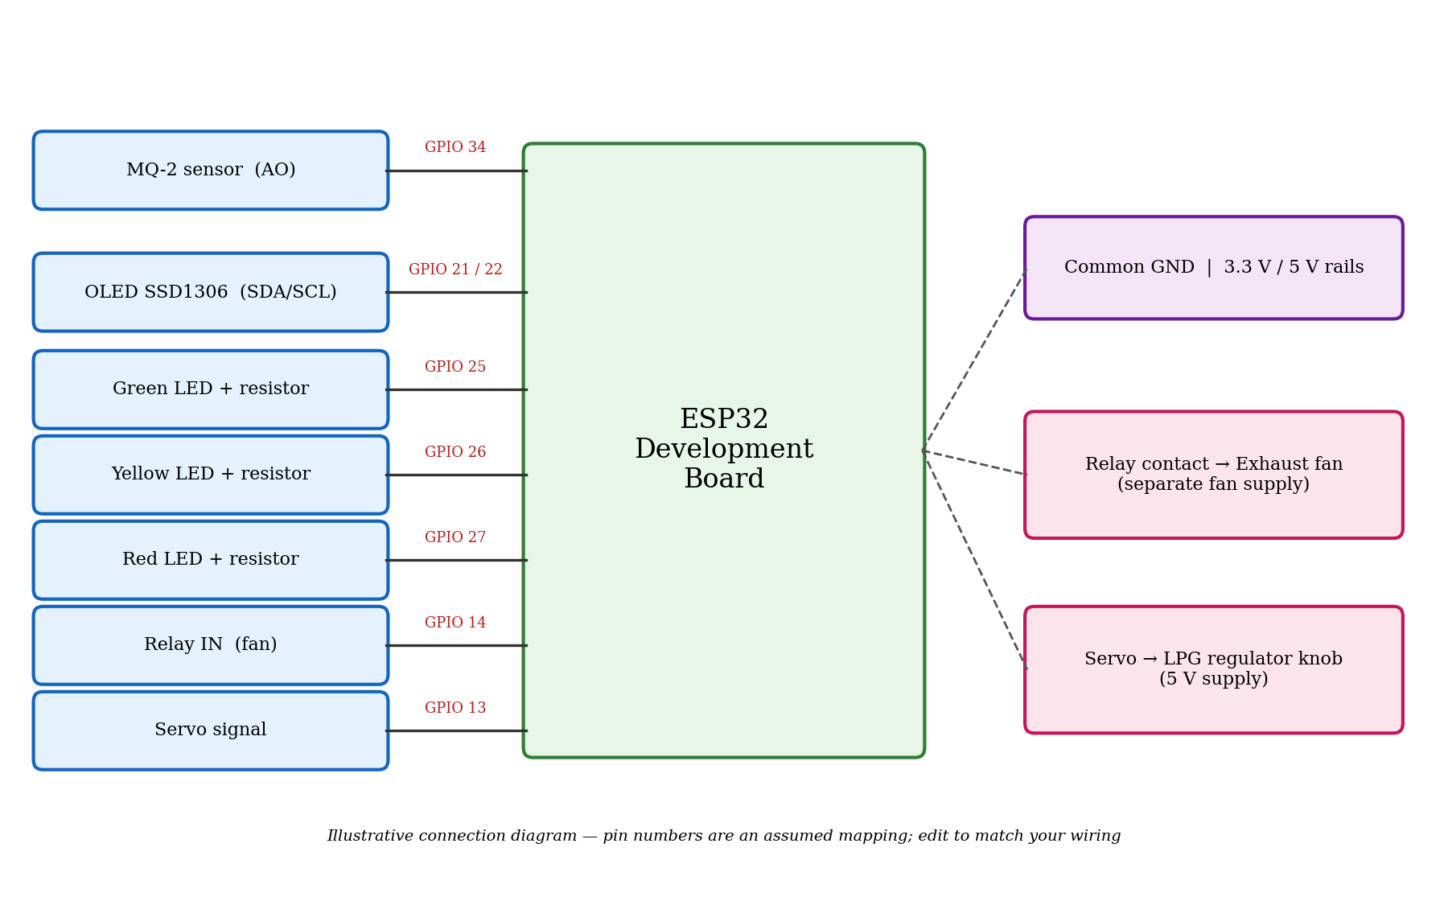
Figure 3.12 – Circuit connection diagram of GasGuard
Table 3.4 – Pin mapping of the prototype
Device | ESP32 pin | Remarks
MQ-2 analog output (AO) | [GPIO 34] | ADC1 input; confirm that the voltage never exceeds 3.3 V
OLED SDA / SCL | [GPIO 21 / 22] | I2C bus, typical address 0x3C
Green LED | [GPIO 25] | Through a series resistor
Yellow LED | [GPIO 26] | Through a series resistor
Red LED | [GPIO 27] | Through a series resistor
Relay input (fan) | [GPIO 14] | Relay module logic level to be confirmed
Servo signal | [GPIO 13] | PWM signal; servo powered from a suitable supply
The pin numbers above are an assumed mapping; replace them with the pins used in your wiring and update the source code to match.

3.4.3 Design Considerations for the Sensor Interface
The ESP32 analog input accepts a maximum of about 3.3 V. Many MQ-2 modules are powered from 5 V and their analog output can swing towards the supply voltage in the presence of gas. If this is the case for the module in use, the output must be reduced with a resistor divider, or the module must be powered so that its output stays within the ADC range, before it is connected to the ESP32. The ADC itself is not perfectly linear, especially near the ends of its range, which is another reason for calibrating the thresholds against measurements taken on the actual hardware rather than relying on calculated values.

3.5 SOFTWARE REQUIREMENTS
Table 8 lists the software tools used to build and run GasGuard.
Table 3.5 – Software and tools
Software / tool | Purpose
Windows 10/11 | Development operating system
Arduino IDE | Writing, compiling and uploading the control program to the ESP32
Embedded C/C++ | Programming language for sensing, threshold analysis and safety control
ESP32 board package | Adds ESP32 support to the Arduino IDE [12]
Adafruit GFX and SSD1306 libraries | Drawing text on the OLED display [13]
ESP32Servo library | Generating the servo control signal on the ESP32
Wire library | I2C communication with the OLED
Serial Monitor | Observing sensor values and verifying thresholds and responses during testing
Git and GitHub | Version control and source-code management

3.6 NON-FUNCTIONAL REQUIREMENTS AND DESIGN CONSIDERATIONS
- Safety: the shut-off and ventilation decisions are made locally and do not depend on any external service.
- Responsiveness: the sensor is sampled and evaluated continuously in a short loop so that a rising gas level is acted on without noticeable delay.
- Reliability: the basic non-zero sensor-reading check prevents readings from an unready or faulty sensor from being trusted; the regulator is not re-opened automatically once it has been closed.
- Usability: the colour of the LED and the text on the OLED allow the state to be understood at a glance.
- Low power and low cost: the design uses inexpensive modules and a single microcontroller.
- Maintainability: thresholds and pin numbers are defined as named constants at the top of the program so that they can be changed without altering the logic.
- Extendability: unused pins and the wireless features of the ESP32 allow a load cell, a siren or remote alerts to be added later.
Summary. The system design of GasGuard identifies the limitations of conventional LPG detectors and proposes an integrated solution. The architecture combines a health-checked MQ-2 sensor with an ESP32 controller, local indication, automatic shut-off and ventilation. The specified hardware and software provide a basis for building and testing the system.

CHAPTER 4
IMPLEMENTATION

4.1 METHODOLOGY
The methodology describes the systematic approach used to design, build and test GasGuard. It combines sensor signal acquisition, threshold-based classification and rule-based control of the outputs. Each stage is structured, reproducible and focused on real-time operation.

4.1.1 Research Approach
The work is applied and experimental. Development followed an iterative model of short cycles of the following stages, each verified on the hardware before the next was added:
- Requirement analysis and literature study
- Component selection and circuit design
- Module development and individual testing
- System integration
- Functional validation with a controlled gas source

4.1.2 System Development Stages
The project was divided into sequential but interlinked stages: interfacing the MQ-2 sensor and observing its output on the Serial Monitor; adding the LEDs and the OLED display; defining the thresholds and the four severity states; adding the relay and the exhaust fan; adding the servo and the regulator mechanism; implementing the basic non-zero sensor-reading check; and integrating and testing the complete system.

4.1.3 Reference Values and Calibration Data
GasGuard does not use a pre-collected dataset. The reference values are the threshold levels that separate the four severity states, together with the limits used by the health check. They were determined experimentally by observing the raw ADC readings of the sensor in clean air and under controlled exposure to gas from a lighter, using the Serial Monitor. The thresholds are stored as named constants in the control program (Section 4.2.7).

4.1.4 Signal Acquisition and Classification
The MQ-2 module gives an analog voltage that rises with gas concentration. The ESP32 converts it with its 12-bit ADC into a count between 0 and 4095. The corresponding voltage at the pin is
Vadc = (ADC / 4095) × Vref (1)
where Vref is the full-scale voltage of the ADC channel, approximately 3.3 V for the attenuation setting used. Because a single sample is noisy, the program averages n consecutive samples taken a few milliseconds apart:
ADCavg = (1 / n) Σ ADCk , k = 1 … n (2)
The averaged value is compared with three thresholds T1 < T2 < T3 to obtain the severity state S:
S = Safe if ADCavg < T1; Warning if T1 ≤ ADCavg < T2; Dangerous if T2 ≤ ADCavg < T3; Critical if ADCavg ≥ T3 (3)
To avoid rapid flickering of the LEDs when the reading hovers close to a threshold, a small hysteresis band can be applied when the state falls back to a lower level. Whenever S is DANGER, the control program turns the exhaust fan ON and closes the regulator.

4.1.5 Sensor Health Check
The health check is carried out before gas detection starts and can be repeated during operation. It consists of three conditions:
- Warm-up: the sensor is given a warm-up period after power-on, during which no gas decision is made, because the heated sensing layer needs time to stabilise [10].
- Range check: the average reading must lie between a minimum and a maximum plausible value; a reading stuck at zero or at the top of the range indicates a disconnected, shorted or failed sensor.
- Stability check: a short burst of samples must have a spread (maximum minus minimum) below a limit; a reading that is changing erratically while no gas is present is not trusted.
If any condition fails, the system reports a sensor fault on the display and does not classify gas from that reading. If all conditions are met, the sensor is declared healthy and the severity classification of Section 4.1.4 is carried out.

4.1.6 System Integration and Deployment
All modules run on the single ESP32. After a power-on initialisation, the program enters a continuous loop of health check, measurement, classification, indication and response. No computer is needed during operation; the Arduino IDE is used only to upload the program and the Serial Monitor only for testing. The relay and the servo are driven from the ESP32 pins, with the fan and servo powered from supplies suited to their current requirements.

4.1.7 Testing and Validation
- Sensor verification: the raw MQ-2 readings were observed on the Serial Monitor in clean air and in the presence of gas from a lighter to confirm that the reading rises with gas.
- Threshold verification: the readings that mark the SAFE, WARNING and DANGER states were identified and entered as thresholds.
- Output verification: the LEDs, OLED, relay with fan and servo were each tested individually before integration.
- Integrated testing: a gas lighter was used as a controlled LPG source to produce the different states and to verify the automatic fan and regulator response.
- Performance analysis: detection accuracy, severity and sensor response were evaluated for the Safe, Danger and Critical conditions (Section 5.4.4).

4.1.8 Safety and Ethical Considerations
Testing with flammable gas must be done carefully. The gas lighter was used only in small quantities, in a ventilated area, away from ignition sources and without a flame, and the mock regulator mechanism was used instead of a live cylinder. GasGuard stores no personal data. It is intended as an additional layer of protection and does not replace safe practices such as regular inspection of hoses and regulators, proper ventilation and the use of approved equipment.

4.2 IMPLEMENTATION
The implementation turns the design into a working prototype. The system is divided into independent but connected modules for sensor interfacing and health checking, severity classification, indication and display, ventilation, regulator shut-off and the main control loop. The program is written in Embedded C/C++ in the Arduino IDE for the ESP32.

4.2.1 Module 1: Sensor Interface and Health Check
Technology used. The ESP32 ADC (analogRead on an ADC1 pin), a warm-up timer and the Serial Monitor for observation.
Implementation steps.
- Pin setup: the MQ-2 analog output pin is configured as an input and the ADC resolution is set to 12 bits.
- Warm-up: after power-on, the program waits for the warm-up period and shows a message on the OLED while it does so.
- Sampling: a burst of readings is taken and the average, minimum and maximum are calculated.
- Range and stability tests: the average is compared with the minimum and maximum plausible values and the spread with the stability limit.
- Result: the module returns healthy or faulty, and a fault is displayed.
Output. A decision on whether the sensor can be trusted, and a filtered reading when it can.

4.2.2 Module 2: Gas Level Processing and Severity Classification
Technology used. Threshold comparison written as a classification function; named constants for T1, T2 and T3.
Implementation steps.
- Averaging: n readings are averaged to reduce noise (Equation 2).
- Classification: the averaged value is compared with T1, T2 and T3 to give Safe, Warning, DANGER (Equation 3).
- Hysteresis: a small margin is applied when stepping down to a lower state so that the state does not flicker.
- Logging: the raw and averaged values and the state are printed to the Serial Monitor for verification.
Output. The current severity state of the environment.

4.2.3 Module 3: Indication and Display
Technology used. GPIO outputs for the LEDs; the Adafruit SSD1306 library over I2C for the OLED.
Implementation steps.
- LEDs: green is switched on for Safe, yellow for Warning and red for Dangerous and Critical; the others are switched off.
- OLED: the display is cleared and the state name is written in large text, with the numerical reading in smaller text.
- Update: the display is refreshed in every cycle so that it always shows the current condition.
Output. A visible and readable indication of the current state at the device.

4.2.4 Module 4: Ventilation Control
Technology used. A GPIO output driving the input of a 1-channel relay module that switches the exhaust fan.
Implementation steps.
- Trigger: when the state is DANGER, the relay output is set to the ON level.
- Hold: the fan is kept on while the state remains at these levels and for a short hold time afterwards so that the gas is fully cleared.
- Release: when the state returns to Safe or Warning and the hold time has expired, the relay is switched off.
Output. Automatic ventilation of the area while a dangerous leak is present.

4.2.5 Module 5: Regulator Shut-Off
Technology used. The ESP32Servo library, which generates the servo control signal.
Implementation steps.
- Positions: an open angle and a closed angle of the servo are defined as constants.
- Trigger: when the state is DANGER, the servo is rotated to the closed angle to turn the regulator OFF.
- Latching: once the regulator has been closed it stays closed, even if the gas level falls, until the system is reset or the regulator is re-opened manually after the cause of the leak has been found.
Output. An automatic stop of the LPG supply on a dangerous leak.

4.2.6 Module 6: Main Control Loop
Technology used. The Arduino setup() and loop() functions of the ESP32 program.
Implementation steps.
- Setup: initialise the serial port, the pins, the OLED and the servo, move the servo to the open position, and run the warm-up and the first health check.
- Loop: repeat the health check, read the averaged value, classify the severity, update the LEDs and display, and apply the fan and regulator rules.
- Fault handling: if the health check fails, show the fault and skip gas classification for that cycle.
Output. Continuous, autonomous monitoring and response.

4.2.7 Calibration of Thresholds
The thresholds T1, T2 and T3 and the limits of the health check were set experimentally. First the sensor was warmed up and the reading in clean air was recorded for a period to find the baseline and its spread. Then small amounts of gas from a lighter were released near the sensor and the readings corresponding to a noticeable, a dangerous and a severe leak were observed. The thresholds were placed between these levels with margins above the clean-air baseline so that noise does not cause false warnings. Table 9 records the calibration values used in the prototype.
Table 4.1 – Calibration values used in the prototype
Parameter | Symbol | Value (ADC counts)
Clean-air baseline reading | ADCbase | 500
Warning threshold | T1 | 1700
Dangerous threshold | T2 | 3000
Critical threshold | T3 | 3500
Minimum plausible reading | ADCmin | 1
Maximum plausible reading | ADCmax | 4095
Maximum stable spread | Δmax | 100
Warm-up period | tw | 60 seconds

4.2.8 Execution Flow
- The device is powered on and all pins, the OLED and the servo are initialised; the regulator is held open.
- The sensor warms up while the display shows a warm-up message.
- The basic non-zero sensor-reading check runs; on failure a sensor fault is shown and the check repeats.
- The ESP32 reads and averages the MQ-2 output.
- The averaged value is classified as Safe, Warning, DANGER.
- The LED and OLED are updated to show the state.
- For DANGER, the exhaust fan is switched ON and the servo turns the regulator OFF.
- The loop continues, so that the display always reflects the current condition.

4.2.9 Design Rationale
- Health check first: a sensor that has not warmed up or has failed must not be trusted to say that the air is safe.
- Four severity states: a warning for a trace of gas and automatic action only for a real danger avoids unnecessary shut-offs and false confidence.
- Local control: safety actions depend only on hardware that is on the device, so the system works when the network does not.
- Latched regulator: automatic re-opening of a gas supply after a leak would be unsafe, so a person must restore it.
- Relay for the fan: a relay isolates the ESP32 from the fan current and lets any suitable fan be used.
- Named constants: thresholds and pins are collected at the top of the program for easy recalibration.

4.3 THEORETICAL BACKGROUND
This section explains the principles on which the GasGuard hardware and algorithm rely. They are standard results for the components used and are given here so that the thresholds, the circuit and the control logic can be understood and reproduced.

4.3.1 Working Principle of the MQ-2 Sensor
The MQ-2 is a chemiresistive sensor. Its sensing element is a tin dioxide (SnO2) layer heated by an internal coil. In clean air, oxygen molecules adsorbed on the heated surface capture free electrons from the semiconductor, which leaves the layer with a high resistance. When a reducing gas such as LPG is present, it reacts with the adsorbed oxygen and releases the electrons back, so the resistance of the layer, Rs, falls. The greater the gas concentration, the lower Rs becomes [10].
In the sensor module the sensing layer forms a voltage divider with a load resistor RL connected across the supply voltage Vc. The voltage across the load resistor, which is the analog output, is
Vout = Vc × RL / (Rs + RL) (4)
so a fall in Rs makes Vout rise. Solving Equation 4 for the sensor resistance gives
Rs = RL × (Vc − Vout) / Vout (5)
The data sheet describes the sensitivity of the sensor by the ratio Rs/R0, where R0 is the resistance in clean air [10]. This ratio falls as the gas concentration rises, approximately along a straight line on a log–log scale for a given gas. GasGuard does not convert the reading into parts per million. It uses the raw ADC count and fixed thresholds, because the aim is a reliable severity decision and not a calibrated concentration measurement; the conversion would require a calibration curve for the particular sensor.

4.3.2 Warm-Up and Drift
The sensing layer works only at an elevated temperature, which the heater provides. After power-on, the layer takes time to reach a steady temperature and the reading drifts while it does so. The manufacturer therefore specifies a preheating period before measurements are taken [10]. The output also depends on ambient temperature and humidity and changes slowly as the sensor ages. These properties are the reason for the warm-up stage and the stability check in the health module, and for the recommendation to recalibrate the thresholds periodically.

4.3.3 Analog-to-Digital Conversion in the ESP32
The ESP32 contains a successive-approximation ADC with up to 12-bit resolution, which divides the input range into 4096 levels [11]. With the 11 dB attenuation setting used in the program the usable input range is roughly 0 to 3.3 V, so one count corresponds to about 0.8 mV and Equation 1 gives the pin voltage. The converter is not perfectly linear, particularly near the lowest and highest counts, and individual chips differ slightly. For a threshold-based system this is acceptable, provided the thresholds are set from measurements on the actual board, as in Section 4.2.7. The ADC1 channels are used for the sensor because ADC2 shares hardware with the Wi-Fi radio.

4.3.4 Noise Reduction by Averaging
A single ADC sample contains noise from the sensor, the supply and the converter. Averaging n independent samples reduces the random part of the noise roughly in proportion to the square root of n. GasGuard averages ten samples for the gas level, which is a compromise: more samples give a smoother value but lengthen the time taken for each decision. With samples taken a few milliseconds apart, the averaging adds only a small delay compared with the speed at which a gas concentration changes in a room.

4.3.5 Hysteresis
If the classification used a single fixed threshold for each direction, a reading that hovers around the threshold would switch the state back and forth, causing the LED and display to flicker and the fan to chatter. Hysteresis uses a lower threshold for stepping down than for stepping up. In Listing 1, the state falls back only when the value is below the threshold minus a margin. The fan has an additional hold time, so that it keeps running for a short period after the gas level drops, to clear the remaining gas.

4.3.6 Servo Positioning
A hobby servo is controlled by a pulse repeated about every 20 ms (50 Hz); the width of the pulse, typically between about 1 ms and 2 ms, sets the shaft angle. The ESP32Servo library generates this pulse with the ESP32 timer hardware, so no continuous attention from the main program is needed. GasGuard uses two positions, open and closed, and the closed position is held by the servo while the pulse continues. The torque of a small servo is limited, so the regulator knob must turn easily, and a mechanical design that gives a reliable and fully closing action must be checked on the actual regulator.

4.3.7 Relay Switching
A relay is an electromagnetic switch. A small current in the coil closes contacts that can carry a larger current in a separate circuit. A typical relay module includes a transistor driver and an optocoupler or similar isolation so that a GPIO pin can drive it directly. Many modules are active-low, which means that the relay closes when the input is pulled low, and the program defines the on and off levels as constants to cover both cases. The relay must be rated for the voltage and current of the fan, and a mains-powered fan involves hazardous voltages that call for proper insulation and an enclosure.

4.3.8 I2C Communication with the OLED
The I2C bus uses two lines, a data line (SDA) and a clock line (SCL), shared by all devices on the bus, each identified by an address. The SSD1306-based OLED commonly responds at address 0x3C [13]. The Adafruit library holds the screen image in a buffer in memory and sends it to the display when display() is called, which is why the program draws the full screen and then updates it once per cycle.

4.4 INSTALLATION, OPERATION AND MAINTENANCE

4.4.1 Component Specifications
Table 10 gives the main characteristics of the components as typically specified by their manufacturers. The values should be checked against the data sheets of the exact parts used.
Table 4.2 – Typical specifications of the main components
Component | Typical characteristics
ESP32 development board | Dual-core 32-bit processor; 3.3 V logic; 12-bit ADC; I2C, PWM and GPIO peripherals; Wi-Fi and Bluetooth (not used in the prototype) [11]
MQ-2 sensor module | SnO2 sensing layer with heater; powered from the supply specified on the module; analog and digital outputs; responds to LPG, propane, methane, hydrogen and smoke [10]
OLED display | 128 × 64 pixel monochrome display; SSD1306 controller; I2C interface; low current [13]
1-channel relay module | Relay with driver stage; input from a GPIO pin; contact rating must exceed the fan load
Servo motor | Small hobby servo; 50 Hz pulse control; operating voltage as specified for the model
LEDs | Green, yellow and red indicators; each with a series current-limiting resistor
Exhaust fan | Small fan suited to the supply used in the prototype

4.4.2 Bill of Materials
Table 11 lists the items needed to build the prototype. The quantities follow from the design; the prices are to be filled in from the receipts so that the cost of the system can be stated in the report.
Table 4.3– Bill of materials
S.No | Item | Qty | Unit price (Rs.) | Amount (Rs.)
1 | ESP32 development board | 1 | 450 | 450
2 | MQ-2 gas sensor module | 1 | 150 | 150
3 | Servo motor | 1 | 180 | 180
4 | 1-channel relay module | 1 | 80 | 80
5 | Exhaust fan | 1 | 250 | 250
6 | OLED display (I2C) | 1 | 180 | 180
7 | LEDs (green, yellow, red) and resistors | 3 each | 30 | 90
8 | Breadboard, jumper wires, power supply | 1 set | 250 | 250
 | Total |  |  | 1630

4.4.3 Installation Guide
- Mount the MQ-2 sensor low on the wall near the cylinder, because LPG vapour is heavier than air and collects near the floor, and keep it away from direct airflow from fans, stove flames and sources of steam.
- Mount the ESP32 unit, the display and the LEDs at a visible position that is not exposed to heat or moisture.
- Fix the servo so that its arm engages the regulator knob and turns it fully closed at the closed angle, and check that the knob can still be turned by hand.
- Place the exhaust fan so that it vents air from the low part of the room to the outside, and connect it through the relay with a supply suited to its rating.
- Make all connections with the power off, join the grounds together, and check the polarity of the supplies before switching on.
- Power the system, wait for the warm-up period and check that the Safe state is displayed in clean air.
- Calibrate the thresholds as described in Section 4.2.7 and record the values in Table 9.

4.4.4 Operating Instructions
In normal use the green LED is lit and the OLED shows SAFE. A yellow LED and the text WARNING mean that gas has been detected at a low level: the user should check the cylinder, the hose and the appliance and ventilate the room. A red LED with DANGER or CRITICAL means that the regulator has been closed and the fan switched on automatically. The user should not operate electrical switches or any flame, should leave the fan running and open the doors and windows, and should have the installation inspected before the regulator is opened again by hand. The regulator stays closed after a dangerous leak until the system is reset or the regulator is re-opened manually. A SENSOR FAULT message means that the gas sensor cannot be trusted and must be inspected or replaced.

4.4.5 Maintenance
- Check the sensor reading in clean air at regular intervals and recalibrate the thresholds if the baseline has drifted.
- Test the response from time to time with a small controlled gas exposure, following the safety precautions of Section 4.1.8.
- Check that the servo still closes the regulator fully and that the fan and relay work.
- Keep the sensor free of dust, grease and moisture, and replace it if its readings become unstable.
- Inspect hoses, regulators and connections of the LPG installation regularly, because GasGuard is an additional safeguard and not a replacement for these checks.

4.4.6 Troubleshooting
Table 12 lists common problems that may be met while building and using the prototype and the usual causes.
Table 4.4 – Troubleshooting guide
Symptom | Likely cause | Remedy
Reading always near zero | Sensor not connected, wrong pin, or output not reaching the ADC pin | Check wiring and the ADC1 pin; check the module supply
Reading stuck at the maximum | Sensor output above the ADC range, short circuit or failed sensor | Check the voltage at the pin; reduce it with a divider if needed
Readings drift or jump in clean air | Sensor not warmed up, supply noise, or unstable power | Allow more warm-up; improve the power supply and grounding
False warnings | Thresholds too low, smoke or vapour near the sensor | Recalibrate; relocate the sensor
Fan does not start | Relay logic level reversed, insufficient supply, or loose wiring | Change RELAY_ON and RELAY_OFF; check the fan supply
Servo twitches or the ESP32 resets | Servo drawing too much current from the supply | Use a separate servo supply with a common ground
OLED blank | Wrong I2C address or wiring | Check SDA and SCL and the 0x3C address
Regulator does not close fully | Mechanical coupling or angle | Adjust the closed angle or the mounting

4.4.7 Safety Precautions
- Do not test with an open flame near gas; release gas only in small quantities and in a ventilated place.
- Isolate and enclose any mains-powered fan wiring and use a relay and fan rated for the load.
- Do not rely on the prototype as the only protection for a live installation.
- After any automatic shut-off, find and repair the cause of the leak before opening the regulator.

CHAPTER 5. CONCLUSION AND FUTURE WORK

5.1 CONCLUSION
The project “GasGuard: Intelligent LPG Leak Detection and Automatic Safety Response System” was developed to close the gap between detecting an LPG leak and doing something about it. Most low-cost detectors sense gas and sound an alarm but leave the response to a person, and few check the health of their own sensor. GasGuard addresses this by verifying the sensor, classifying the leak into four severity states and acting automatically, using an ESP32, an MQ-2 sensor and simple actuators.

5.1.1 Purpose and Achievements
- A basic non-zero sensor-reading check, comprising warm-up, range and stability conditions, carried out before gas detection.
- Real-time detection of LPG with the MQ-2 sensor and classification into SAFE, WARNING and DANGER.
- Local indication through green, yellow and red LEDs and a status display on an OLED.
- Automatic regulator shut-off through a servo motor and automatic ventilation through a relay-driven exhaust fan on Dangerous and Critical leaks.
- Operation without cloud, internet or GSM connectivity.
- A tested prototype that responded correctly to gas released from a lighter, with detection accuracy of 100% for the Safe, Danger and Critical conditions tested.

5.1.2 Significance of the System
By acting automatically and locally, GasGuard shortens the time between the start of a leak and the protective response and reduces dependence on someone being present. By checking the sensor first, it reduces the risk that a silent sensor fault gives a false sense of safety. By grading the leak, it makes the response proportionate. The design uses inexpensive parts and is simple enough to be built, understood and extended by students, which makes it a practical basis for low-cost domestic and small-commercial LPG safety.

5.1.3 Challenges Faced
- Stable sensor readings: obtaining stable MQ-2 readings was difficult at first, because the raw output drifts and fluctuates.
- Warm-up time: the sensor needs sufficient warm-up time before its readings are meaningful, which led to the warm-up stage of the health check.
- Consistent gas exposure: it is hard to maintain a consistent gas concentration when a lighter is the source, so the readings vary from trial to trial.
- Threshold selection: the thresholds had to be chosen from observed values and placed with margins so that noise does not cause false states.
- Interfacing actuators: the relay and servo required separate attention to supply and signal levels so that the ESP32 was not loaded.

5.1.4 Social and Ethical Impact
LPG accidents cause injury, death and loss of property every year, particularly in homes and small eateries that cannot afford sophisticated safety systems. A low-cost device that reacts automatically can make such protection more widely available. GasGuard stores no personal data and does not rely on an external service. It is intended as an additional safeguard and not a replacement for safe practice and approved equipment.

5.1.5 Limitations
- The results come from functional testing of a prototype with a gas lighter as the source; the sensor has not been calibrated against known gas concentrations.
- The MQ-2 is not selective: smoke, alcohol vapour and other combustible gases can also raise the reading.
- Sensor output depends on temperature and humidity and drifts with age; thresholds must be recalibrated for every sensor and installation.
- The regulator shut-off was demonstrated with a servo-operated mock mechanism and has not been tested on a live cylinder installation.
- There is no audible alarm and no weight monitoring in the current prototype.
- The system has not been tested over long periods or in a wide range of environmental conditions.
In conclusion, GasGuard shows that a verified sensor, a graded severity analysis and automatic local action can be combined in a low-cost ESP32-based system that responds to an LPG leak without waiting for a person or a network. Calibration with reference gas concentrations and testing under varied conditions are the most important next steps.

5.2 FUTURE WORK
The present system detects, classifies and responds to LPG leaks locally. Future work will focus on added safety functions, better sensing and proper evaluation:
- Cylinder weight monitoring: add a load cell to weigh the cylinder and warn the user when a refill is needed, and to provide an independent indication of unusual gas loss.
- Audible alarm: add a buzzer or siren so that an alarm can be raised over a greater distance.
- Wider testing: test the system under a variety of temperatures, humidity levels and gas exposure levels to confirm its reliability and practicality.
- Calibration: calibrate the thresholds against known gas concentrations and apply temperature and humidity compensation.
- Improved sensing: evaluate other gas sensors or combine more than one sensor to reduce false alarms from smoke and vapours.
- Remote notification: add optional wireless or SMS alerts as an extra layer while keeping the local automatic response as the primary safety mechanism.
- Real valve integration: replace the mock mechanism with a certified solenoid valve or regulator actuator and test it on a controlled installation.
- Event logging: record events with time stamps for later analysis and maintenance.
- Enclosure and power: design a protective enclosure and a battery backup so that the unit keeps working during power failure.
Through such developments GasGuard can grow from a laboratory prototype into a dependable low-cost safety device for kitchens and small commercial premises.

5.3 SOURCE CODE
Table 5.1– source code

Listing | Part of GasGuard.ino | Role
1 | Configuration and helper functions | Pin mapping, thresholds, sensor averaging, health check, classification, LED, OLED, fan and regulator functions
2 | setup() and loop() | Initialisation, warm-up, and the continuous monitoring and response loop
The following listing is the complete ESP32 Arduino program supplied for the current GasGuard implementation. It uses an MQ-2 sensor, three status states (SAFE, WARNING and DANGER), an SSD1306 OLED, three LEDs, a relay-controlled fan and a servo actuator. The ADC thresholds are provisional and should be calibrated against the actual sensor and test conditions.
Listing 1 – Complete GasGuard ESP32 source code
#include <Wire.h>
#include <Adafruit_GFX.h>
#include <Adafruit_SSD1306.h>
#include <ESP32Servo.h>

// ================= OLED =================
#define SCREEN_WIDTH 128
#define SCREEN_HEIGHT 64
#define OLED_RESET -1
#define OLED_ADDRESS 0x3C

#define OLED_SDA 21
#define OLED_SCL 22

// ================= PINS =================
#define MQ2_PIN 34
#define SERVO_PIN 13
#define RELAY_PIN 26

#define GREEN_LED 25
#define YELLOW_LED 32
#define RED_LED 33

// ================= CONFIGURATION =================

// Relay module is active-LOW
#define RELAY_ACTIVE_LOW true

// Provisional raw ADC thresholds
const int WARNING_THRESHOLD = 1700;
const int DANGER_THRESHOLD = 3000;

// ================= OBJECTS =================
Adafruit_SSD1306 display(
SCREEN_WIDTH, SCREEN_HEIGHT, &Wire, OLED_RESET
);

Servo gasServo;

// ================= VARIABLES =================
int gasRaw = 0;
int servoAngle = 0;
bool fanOn = false;
bool sensorFound = false;

const char* status = "SAFE";

// ================= FAN CONTROL =================
void setFan(bool on) {
fanOn = on;

if (RELAY_ACTIVE_LOW) {
digitalWrite(RELAY_PIN, on ? LOW : HIGH);
} else {
digitalWrite(RELAY_PIN, on ? HIGH : LOW);
}
}

// ================= LED CONTROL =================
void setLEDs(bool green, bool yellow, bool red) {
digitalWrite(GREEN_LED, green ? HIGH : LOW);
digitalWrite(YELLOW_LED, yellow ? HIGH : LOW);
digitalWrite(RED_LED, red ? HIGH : LOW);
}

// ================= SETUP =================
void setup() {
Serial.begin(115200);

pinMode(RELAY_PIN, OUTPUT);
pinMode(GREEN_LED, OUTPUT);
pinMode(YELLOW_LED, OUTPUT);
pinMode(RED_LED, OUTPUT);

// Safe initial outputs
setFan(false);
setLEDs(true, false, false);

analogReadResolution(12);
analogSetPinAttenuation(MQ2_PIN, ADC_11db);

// Initialize OLED
Wire.begin(OLED_SDA, OLED_SCL);

if (!display.begin(SSD1306_SWITCHCAPVCC, OLED_ADDRESS)) {
Serial.println("OLED initialization failed!");
while (true) {
delay(1000);
}
}

// Initialize servo
gasServo.setPeriodHertz(50);
gasServo.attach(SERVO_PIN, 500, 2400);
gasServo.write(0);

display.clearDisplay();
display.setTextColor(SSD1306_WHITE);

display.setTextSize(2);
display.setCursor(5, 0);
display.println("GASGUARD");

display.drawLine(0, 19, 127, 19, SSD1306_WHITE);

display.setTextSize(1);
display.setCursor(10, 32);
display.println("Initializing...");
display.setCursor(10, 45);
display.println("MQ-2 Sensor");

display.display();

Serial.println("GASGUARD STARTED");
Serial.println("MQ2 | HEALTH | STATUS | FAN | SERVO");
}

// ================= MAIN LOOP =================
void loop() {
// Average 10 readings
long total = 0;

for (int i = 0; i < 10; i++) {
total += analogRead(MQ2_PIN);
delay(5);
}

gasRaw = total / 10;

// Sensor health indication
sensorFound = (gasRaw > 0);

// Determine gas state and outputs
if (gasRaw >= DANGER_THRESHOLD) {
status = "DANGER";
servoAngle = 180;

setLEDs(false, false, true);
setFan(true);
}
else if (gasRaw >= WARNING_THRESHOLD) {
status = "WARNING";
servoAngle = 90;

setLEDs(false, true, false);
setFan(true);
}
else {
status = "SAFE";
servoAngle = 0;

setLEDs(true, false, false);
setFan(false);
}

// Command servo using its external 5V supply
gasServo.write(servoAngle);

// ================= OLED DISPLAY =================
display.clearDisplay();
display.setTextColor(SSD1306_WHITE);

// Large title
display.setTextSize(2);
display.setCursor(5, 0);
display.println("GASGUARD");

display.drawLine(0, 19, 127, 19, SSD1306_WHITE);

display.setTextSize(1);

display.setCursor(0, 22);
display.print("MQ2 RAW: ");
display.println(gasRaw);

display.setCursor(0, 32);
display.print("HEALTH: ");
display.println(sensorFound ? "OK" : "0");

if (!sensorFound) {
display.setCursor(0, 42);
display.println("SENSOR NOT FOUND");

display.setCursor(0, 53);
display.print("STATUS: ");
display.println(status);
}
else {
display.setCursor(0, 42);
display.print("STATUS: ");
display.println(status);

display.setCursor(0, 53);
display.print("SV:");
display.print(servoAngle);
display.print(" FAN:");
display.println(fanOn ? "ON" : "OFF");
}

display.display();

// ================= SERIAL MONITOR =================
Serial.print("RAW: ");
Serial.print(gasRaw);

Serial.print(" | SENSOR HEALTH: ");
Serial.print(sensorFound ? "OK" : "SENSOR NOT FOUND");

Serial.print(" | STATUS: ");
Serial.print(status);

Serial.print(" | FAN: ");
Serial.print(fanOn ? "ON" : "OFF");

Serial.print(" | SERVO: ");
Serial.println(servoAngle);

delay(500);
}

5.4 RESULTS

5.4.1 Functional Testing Results
Table 5.2 – Summary of functional tests
Feature | Observed result
MQ-2 sensing of LPG (gas lighter as source) | Successful; reading rises with gas
Sensor warm-up and health check | Upto 60 seconds
Severity classification | Four states defined by thresholds; Safe, Danger and Critical shown on the display
Green / yellow / red LED indication | Working
OLED status display | Working (Figures 15 to 17)
Exhaust fan through relay | Switched ON at the Dangerous and Critical levels
Servo-operated regulator shut-off | Regulator turned OFF at the Dangerous and Critical levels
Operation without cloud or GSM | Confirmed; no network module is used

5.4.2 Sensor Verification
The MQ-2 sensor was first tested on its own. After the warm-up period, the raw reading in clean air stayed within a narrow band. When gas from a lighter was released near the sensor, the reading rose promptly, and it fell again as the gas dispersed. This confirmed that the sensor and the ADC channel respond as expected and provided the values from which the thresholds were chosen. The main difficulties observed were the need for sufficient warm-up time, the variation of the readings and the difficulty of maintaining a constant gas exposure by hand.

5.4.3 Severity Classification and Automatic Response
The integrated prototype was then tested with a gas lighter as a controlled LPG source. In clean air the system showed the Safe state with the green LED. As gas was introduced, the state changed through the levels defined by the thresholds, with the LED colour and the OLED text following the state. At the Dangerous and Critical levels, the exhaust fan was switched ON through the relay and the servo turned the regulator mechanism OFF. The system remained responsive and continued to display the current state. The status screens for the Safe, Danger and Critical conditions are shown in Figures 15 to 17.

5.4.4 Performance Analysis
Figure 18 shows the performance of the system under the Safe, Danger and Critical conditions, and Table 15 gives the values. The detection accuracy remained 100% in all three conditions. The severity level increased from 33% to 67% and 100%, while the MQ-2 sensor response rose from 44.6% to 52.4% and 100%. These results show that the system detects and classifies different LPG leakage levels. They come from a single prototype and a controlled source, and they should not be read as a certified measurement of sensor accuracy.
Table 5.3 – Performance of GasGuard under different conditions
Condition | Detection accuracy | Severity level | MQ-2 sensor response
Safe | 100% | 33% | 44.6%
Danger | 100% | 67% | 52.4%
Critical | 100% | 100% | 100%

5.4.5 Comparison with Existing Systems
Table 16 compares the surveyed systems with GasGuard. Most existing systems concentrate on detection and monitoring, with a limited response such as a cloud backup or a GSM alert, and none of them includes a sensor health indicator. GasGuard combines the basic non-zero sensor-reading check, LPG detection, OLED display, exhaust fan activation and regulator shut-off to give a local and automatic response without a cloud backup or a GSM connection.
Table 5.4 – Feature comparison of existing and proposed systems
S.No | Author | Existing system | Proposed GasGuard
1 | Tukkoji & Kumar [1] | Detects and displays gas level only; no automatic action. | Automatic regulator cut-off and exhaust fan to remove accumulated gas.
2 | Altamash et al. [3] | Uses ML and a camera; no cut-off; cloud dependent. | Automatic cut-off; works without the cloud.
3 | Sitan & Ab Ghafar [5] | Weight monitoring; no automatic action. | OLED display and automatic action.
4 | Pamungkas et al. [7] | Automatic action but no sensor health check. | Sensor health check and automatic action.
5 | Asha et al. [9] | GSM alerts only; no automatic action. | Local automatic action; no GSM module required.

5.5 HARDWARE OUTPUTS
The following figures show the experimental set-up and the outputs of the GasGuard prototype. Figure 14 shows the assembled set-up, Figures 15 to 17 show the status displayed for the Safe, Danger and Critical conditions, and Figure 18 shows the performance analysis.
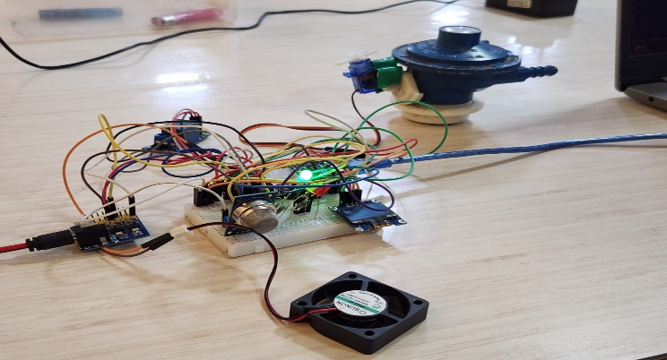
Figure 5.1 – Experimental set-up of the GasGuard prototype
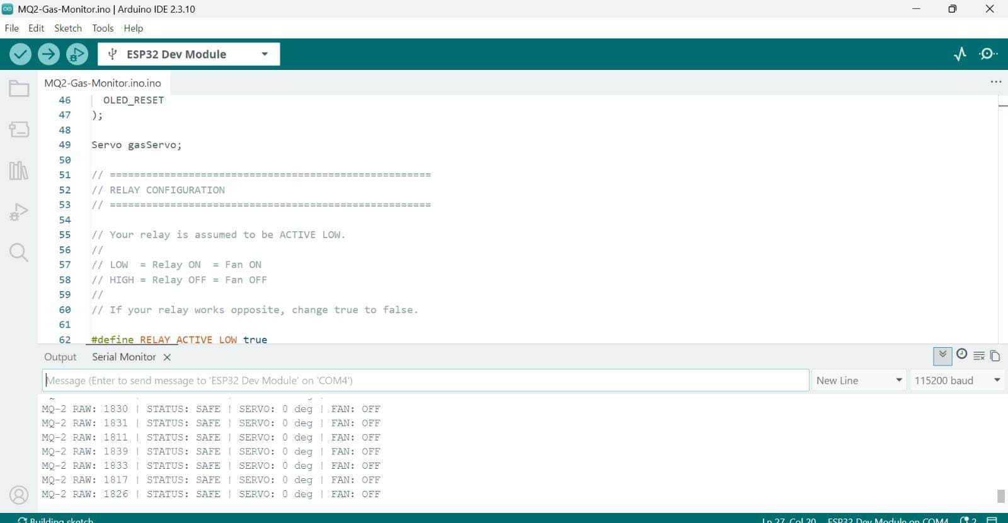
Figure 5.2 – Prototype indicating status SAFE
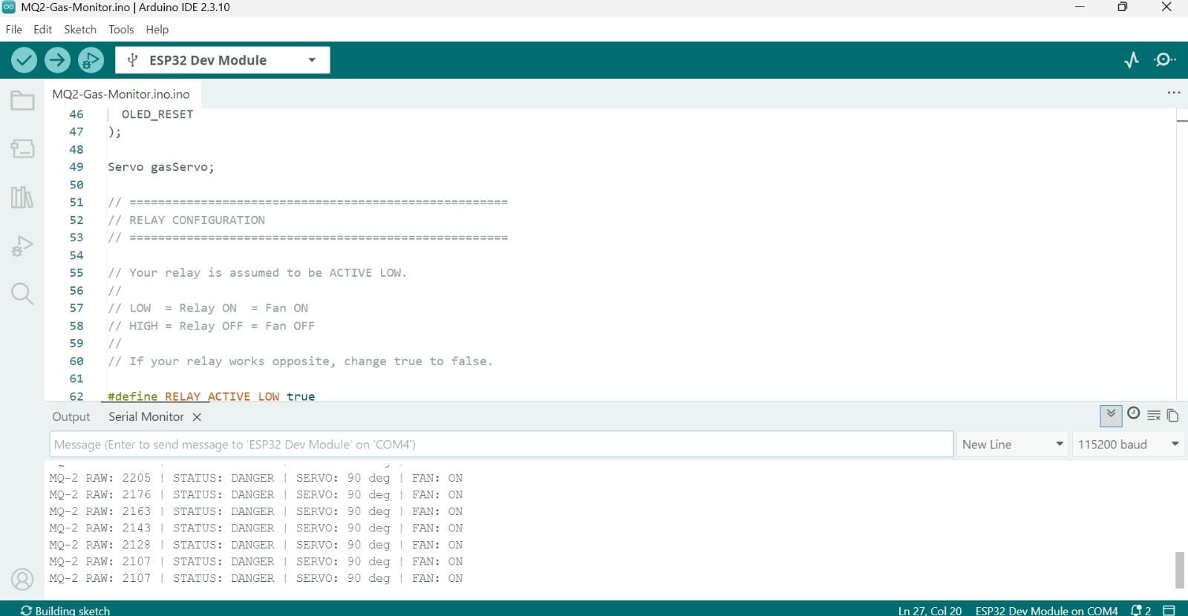
Figure 5.3 – Prototype indicating status DANGER
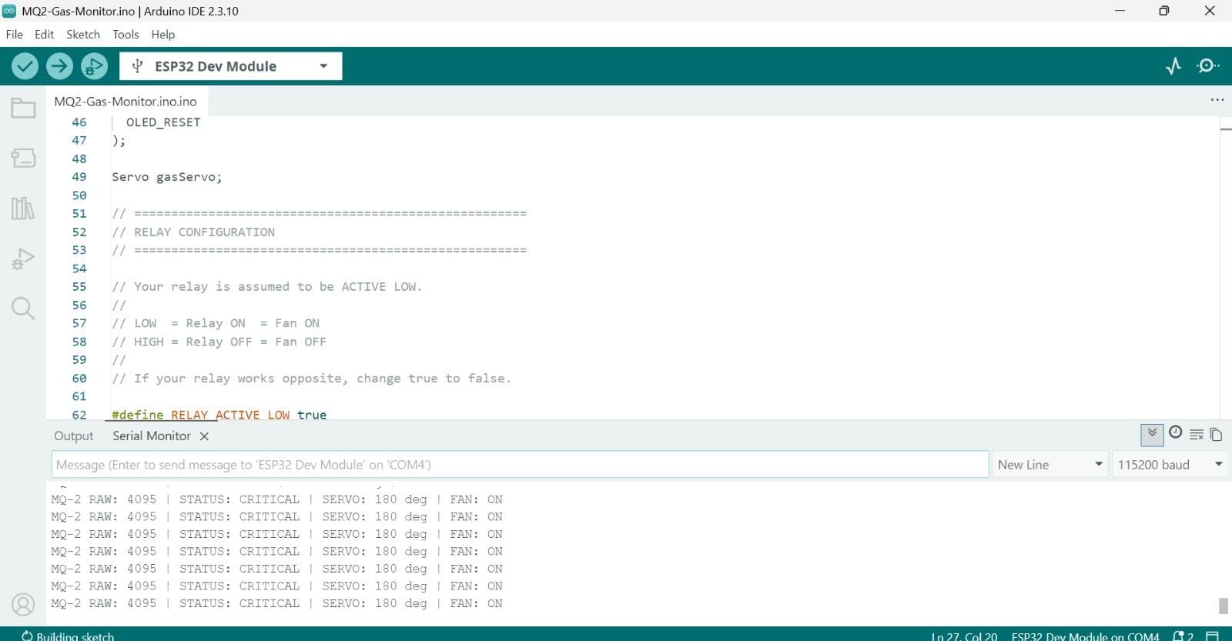
Figure 5.4 – Prototype indicating status CRITICAL
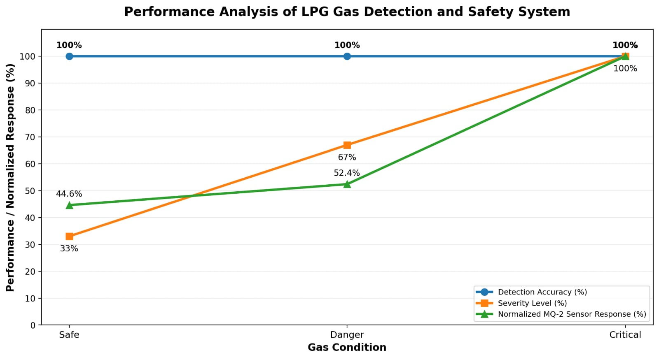
Figure 5.5– Performance analysis of GasGuard

5.4.6 Test Case Matrix
Table 17 lists the test cases defined for the integrated system, the expected behaviour for each and the status recorded. Entries marked for confirmation have no logged observation yet and should be completed from your own test notes before submission.
Table 5.5 – Test case matrix
ID | Test case | Expected behaviour | Status
T1 | Power-on in clean air, after warm-up | Health check passes; Safe state; green LED; OLED shows SAFE | Pass
T2 | Warm-up period | No gas decision until warm-up ends; countdown shown | pass
T3 | Sensor disconnected or output stuck | SENSOR FAULT shown; no gas classification | pass
T4 | Small gas release (lighter, no flame) | Reading rises; Warning state; yellow LED | pass
T5 | Larger gas release | Danger state; red LED; fan ON; regulator OFF | Pass
T6 | Heavy gas release | Critical state; red LED; fan ON; regulator OFF | Pass
T7 | Gas removed after Danger | Level falls; fan runs for hold time then stops; regulator stays OFF | pass
T8 | Reading near a threshold | No rapid flicker of state (hysteresis) | pass
T9 | Operation with no network | All functions work locally | Pass
T10 | Display refresh | OLED shows the current state and fan/regulator status | Pass

5.6 APPENDIX: ALGORITHM
The control algorithm implemented by Listings 1 and 2 is summarised below in pseudo-code form.
INITIALISE pins, ADC (12-bit), OLED, servo
SET fan OFF; SET regulator OPEN; SET LED green
WAIT for sensor warm-up period (display countdown)

LOOP forever:
avg, spread <- sample sensor HEALTH_SAMPLES times
IF avg outside [ADC_MIN, ADC_MAX] OR spread > MAX_SPREAD THEN
show "SENSOR FAULT"; red LED; CONTINUE
value <- average of 10 readings
level <- CLASSIFY(value) with hysteresis
SET LEDs by level
IF level is DANGER THEN
CLOSE regulator (latched)
SET fan ON; fan_hold <- now + FAN_HOLD
ELSE IF fan is ON AND now > fan_hold THEN
SET fan OFF
SHOW level, value, fan and regulator status on OLED
PRINT value and level to Serial Monitor

REFERENCES
[1] C. Tukkoji and S. Kumar A. N., “Design and analysis of smart IoT based gas leakage detection and controlling system,” Int. J. Eng. Appl. Sci. Technol., vol. 4, no. 12, pp. 603–609, Apr. 2020.
[2] A. Gupta, “Efficacious L.P.G. leakage detector and auto shut-off system using Arduino Uno ATmega328,” Int. J. Innov. Res. Sci. Eng. Technol., vol. 6, no. 10, pp. 19971–19978, Oct. 2017.
[3] M. Altamash et al., “Intelligent IoT-based fire and gas leakage detection system: Integrating sensor fusion, edge AI, and visual verification,” Int. J. Eng. Res. Technol. (IJERT), vol. 15, no. 4, Apr. 2026.
[4] S. Anjum, S. Sheikh, I. Aafreen, A. Manapure, and A. Naaz, “IoT based portable gas sensor for smart cities using microcontroller,” Int. J. Adv. Comput. Theory Eng., vol. 14, no. 1, pp. 179–183, 2025.
[5] T. S. Sitan and A. S. Ab Ghafar, “Liquefied petroleum gas (LPG) leakage detection and monitoring system,” J. Sci. Technol., vol. 10, no. 3, pp. 46–53, 2018.
[6] E. I. M. Sohal et al., “G.A.R.D. (Gas Alert and Real-Time Detection): Development of an IoT-enabled gas (LPG) leakage detection with mobile app integration,” The Horizon, vol. 2, no. 1, pp. 24–30, Apr. 2026.
[7] D. R. Pamungkas et al., “Design of Arduino based LPG gas leak detection tool using MQ-2 sensor,” Innov. Technol. Entrepreneur J., vol. 1, no. 1, pp. 21–27, 2024.
[8] D. Novitaningrum, Y. Handayani, and T. Hidayat, “Liquefied petroleum gas (LPG) leak detection mitigation system with MQ-2 sensor based on the Internet of Things (IoT),” Innov. Res. Informatics, vol. 7, no. 2, pp. 127–134, 2025.
[9] D. Asha, K. Vasundhara, P. Ganesh, M. L. Narayana, and K. N. Sai, “IoT based CNG/LPG gas leakage alert and monitoring system,” Int. J. Inf. Electron. Eng., vol. 16, no. 2, pp. 86–94, May 2026.
[10] Hanwei Electronics, “Technical data: MQ-2 gas sensor,” manufacturer data sheet.
[11] Espressif Systems, “ESP32 series datasheet,” manufacturer data sheet. [Online]. Available: https://www.espressif.com
[12] Arduino, “Arduino IDE and ESP32 Arduino core documentation.” [Online]. Available: https://www.arduino.cc
[13] Solomon Systech, “SSD1306 128×64 dot matrix OLED/PLED segment/common driver with controller,” data sheet.
[14] E. Fatkiyah, D. Persada, and D. Andayati, “Early Detection of Leaks on Gas Cylinders Using Arduino Based MQ-6 Sensors,” Journal of Physics: Conference Series, vol. 1413, no. 1, Art. no. 012030, 2019.
[15] S. Ahmed, M. J. Rahman, and M. A. Razzak, “Design and Development of an IoT-Based LPG Gas Leakage Detector for Households and Industries,” in 2023 IEEE World AI IoT Congress (AIIoT), 2023, pp. 762–767.
[16] M. A. F. Malbog, H. D. Grimaldo, L. L. Lacatan, R. M. Dellosa, and Y. D. Austria, “LPG Leakage and Flame Detection with SMS Notification and Alarm System: Rule-Based Method,” in 2020 11th IEEE Control and System Graduate Research Colloquium (ICSGRC), 2020, pp. 323–327.
[17] B. Ravisankar, K. Gurubaran, D. Manoj, R. Nagendran, V. Gowrishankar, and R. Satheesh, “Smart Detection System for LPG Gas Leakage Using IoT,” in 2022 6th International Conference on Computing Methodologies and Communication (ICCMC), 2022, pp. 421–430.
[18] “Internet of Things Based Automatic LPG Gas Leakage Detection and Prevention System,” in 2025 5th International Conference on Trends in Material Science and Inventive Materials (ICTMIM), 2025.
[19] “IoT Based Automatic Electricity Cut Off Using LPG Gas Leakage Detection System,” in 2023 Second International Conference on Electronics and Renewable Systems (ICEARS), 2023.
[20] M. Hannan, A. Mohd Zain, F. Salehuddin, H. Hazura, S. Idris, A. Hanim, A. AH, and N. Mohd Yusoff, “Development of LPG Leakage Detector System Using Arduino with Internet of Things (IoT),” Journal of Telecommunication, Electronic and Computer Engineering, vol. 10, no. 2–7, pp. 91–95, 2018.
[21] S. J. D. Galceran, F. J. H. Villarico, J. J. C. Omao, L. C. P. Estaniel, I. J. P. Saldo, J. R. D. Calo, and M. J. P. Dandoy, “Development and Comparison of Arduino Based MQ-2 and MQ-6 LPG Leak Sensors,” American Journal of Sensor Technology, vol. 7, no. 1, pp. 1–9, 2023.
[22] D. R. Pamungkas, A. Setiawan, and A. Widiyanto, “Design of Arduino-Based LPG Gas Leak Detection Tool Using MQ-6 Sensor,” Innovation, Technology, and Entrepreneurship Journal, vol. 1, no. 1, pp. 21–27, 2024.
[23] F. Muliawati and O. Mustopa, “Monitoring and Control System of IoT-Based Gas Leak Detection,” JuTEkS (Jurnal Teknik Elektro dan Sains), vol. 7, no. 2, 2020.
[24] Triyatno, Ivan, and A. Yudhana, “Protection and Monitoring System for LPG Leaks and Fires in Arduino-Based Rooms,” Buletin Ilmiah Sarjana Teknik Elektro, vol. 5, no. 1, pp. 31–40, 2023.

